**ME5405 Machine Vision**

**Computing Project**



**AY2021/2022 Semester 1**

Wong Jun Zhong Sean (A0173341M)

Huang Yunqi (A0236752B)

Gan Runze (A0242946X)

**Professors:**

Prof. Chui Chee Kong

Prof. Guillaume Adrien Sartoretti

DEPARTMENT OF MECHANICAL ENGINEERING

NATIONAL UNIVERSITY OF SINGAPORE

# Table of Contents

I. Summary II

II. Acknowledgements III

III. Table of Contents IV

IV. List of Figures VI

V. List of Tables VIII

VI. List of Symbols VIII

1. Introduction 1

1.1. Problem 1

1.2. Scope of Project 4

2. Literature Review 5

2.1. Low-Cost Robotic Arms 6

2.2. Legged Robot Platforms 7

3. Development 8

3.1. Mechanical Design 8

3.1.1. First Design - Theoretical Calculations 9

3.1.2. First Design - Prototype 10

3.1.3. First Design - Analysis 11

3.1.4. Second Design – Theoretical Calculations 12

3.1.5. Second Design – Prototype 14

3.1.6. Second Design – Structure 16

3.1.7. Second Design – Cable-Driven Wrist 17

3.1.8. Second Design – Finite Element Analysis 18

3.2. Electrical Design 23

3.3. Software Design 25

3.3.1. Steadywin Control Node 26

3.3.2. Dynamixel Control Node 27

4. Results 28

4.1. Balance Testing 29

4.2. Performance Testing 31

4.3. Miscellaneous Testing 33

4.3.1. Cable-Driven Wrist Results 34

4.3.2. Vibrational Intensity 34

4.3.3. Battery Life 35

4.4. Manipulator Workspace 35

5. Analysis and Discussion 37

6. Conclusions 39

7. Future Developments 40

8. References 42

9. Appendices 45

Appendix A: AlienGo Technical Specifications [33] 45

Appendix B: Derivation of Equation 1 48

Appendix C: Table of Feasibility Calculations 50

Appendix D: Figures for Finite Element Analysis of Pitch Motor and Bearing Mount 51

Appendix E: Figures for Finite Element Analysis of Grass-Cutter Wrist Mount 56

Appendix F: Figures for Balance Testing Results 59

# 1. Introduction

**1.1. General Background**

Provide a general overview of image processing

**1.2. Project Tasks**

Discuss the project tasks and what is required

**1.3. Project Approach Overview**

Provide an overview of -how- we approach the tasks and our thought processes behind why

# 2. Image Processing Application

**2.1. Design Philosophy**

Re-affirm the previous point in section 1.3: discuss the overall concepts of how we are applying the knowledge we have learnt in class as well as our approach to individual problems. Talk about the app and why we chose to do it as a single application. Discuss the benefits of making the app work for images that are not the given images.

**2.2. Display of Original Image**

2.2.1. Considerations for ASCII Behaviour

**2.3. Image Thresholding and Binary Image**

**2.4. Image Skeletonization (One-Pixel Thin Image)**

2.4.1. Custom Method

2.4.2. Matlab Image Toolbox Method

2.4.3. Comparisons

**2.5. Image Outlining**

2.5.1. Custom Method

2.5.2. Matlab Image Toolbox Method

2.5.3. Comparisons

**2.6. Image Segmentation and Labelling**

2.6.1. 4-connectivity Method

2.6.2. 8-connectivity Method

2.6.3. Matlab Image Toolbox Method

2.6.4. Comparisons

**2.7. Image Arrangement**

2.7.1. Methodology

**2.8. Image Rotation**

2.8.1. Custom Method

2.8.2. Interpolation Methods

2.8.3. Matlab Image Toolbox Method

2.8.4. Comparisons

**2.9. Discussions**

Compare between the app and image toolbox methods overall

# 3. Self-Organizing Map Classification

# 4. Conclusions

# 5. Programming Details

This section can be edited later, as it is less important

5.1. Program Operation

5.2. Algorithmic Design

5.3. Process Flowchart

The objective of this project is to design and prototype a robotic arm with an attached grass-cutting tool, as well as any additional hardware and control software, to be used for grass-cutting purposes on the back of a four-legged robot platform.

## 1.1. Problem

Traditionally, grass-cutting in Singapore is conducted by human workers carrying electrical or gasoline-powered cutting tools. These tools generate a significant amount of physical strain when used by humans, primarily due to their vibration and high volume. Records of hand-arm vibration disorder have higher prevalence amongst grass-cutting workers with as high as 81% experiencing changes in finger colour and 36.3% experiencing finger numbness linkable to the operation of the handheld devices [1]. In addition, high numbers of noise-induced hearing impairments affect such workers as well, with nearly 28% contracting mild to moderate impairments [2]. This indicates a significant risk to human workers, and the high noise and vibrational intensities, especially over long working periods, are better suited to robots where it is more practical to dampen such effects on the robot platform itself.

Other than the long-term effects on human workers, operational conditions can often be less than ideal, such as steep slopes shown in Figure 1 below that can be dangerous for humans to work in. Such slopes often require workers to wear protective harnesses and rappel from the peak of the slope in order to perform their work. This is particularly undesirable due to the hazardous conditions for workers, and additionally reduces their working efficiency. Robots with hardware and software that have been designed and optimized for working in such environments, in addition to normal and safe areas, will be important in dealing with this issue.

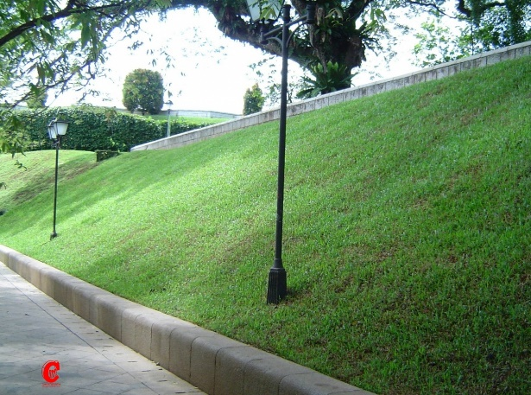 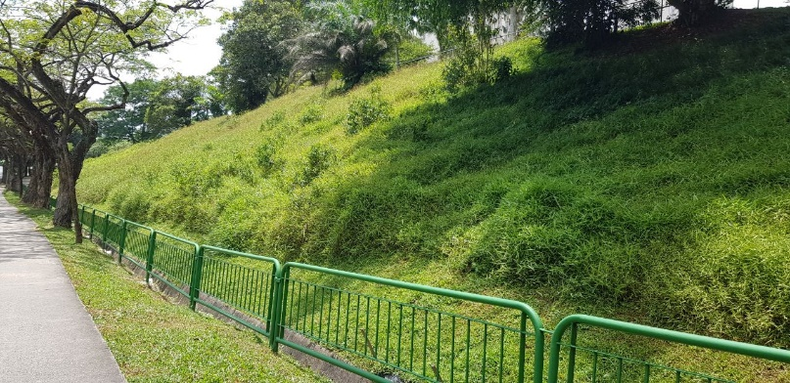

Fig. 1: Human-Inaccessible Steep Slopes [3]

However, currently-marketed automated grass-cutting robots are based on wheeled platforms, such as the Husqvarna Automower 435X AWD shown below in Figure 2. While wheeled platforms are stable and efficient on flat terrain, they are undesirable for a grass-cutting role due to their inherent difficulties in traversing rough surfaces. In the case of sloped terrain, wheeled robots can perform well, and the Automower can traverse slopes of up to 35 degrees. However, the extremely low ground clearance means it will have issues crossing over even the smallest of obstacles. Even state-of-the-art researched designs lean heavily toward wheeled or tracked platforms due to their significantly simpler automation requirements [4] [5] [6].

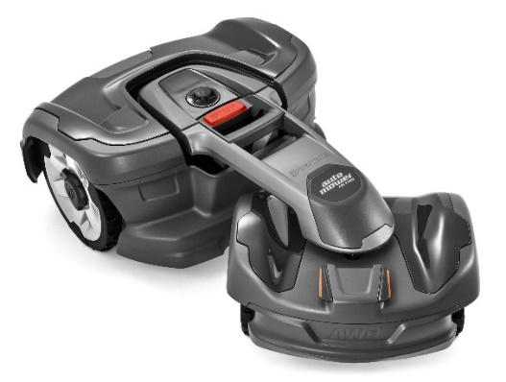

Fig. 2: Husqvarna Automower 435X AWD [7]

In the context of Singapore, patches of grass along avenues, curbs, or on slopes that wheeled robots cannot access without significant assistance are commonly found. An example of a patch of grass in Singapore that is inaccessible to such wheeled robots is shown below in Figure 3. Despite many contemporary designs shying away from such legged robots, it is thus desirable to explore the feasibility of such a legged design in order to tackle these problematic areas.

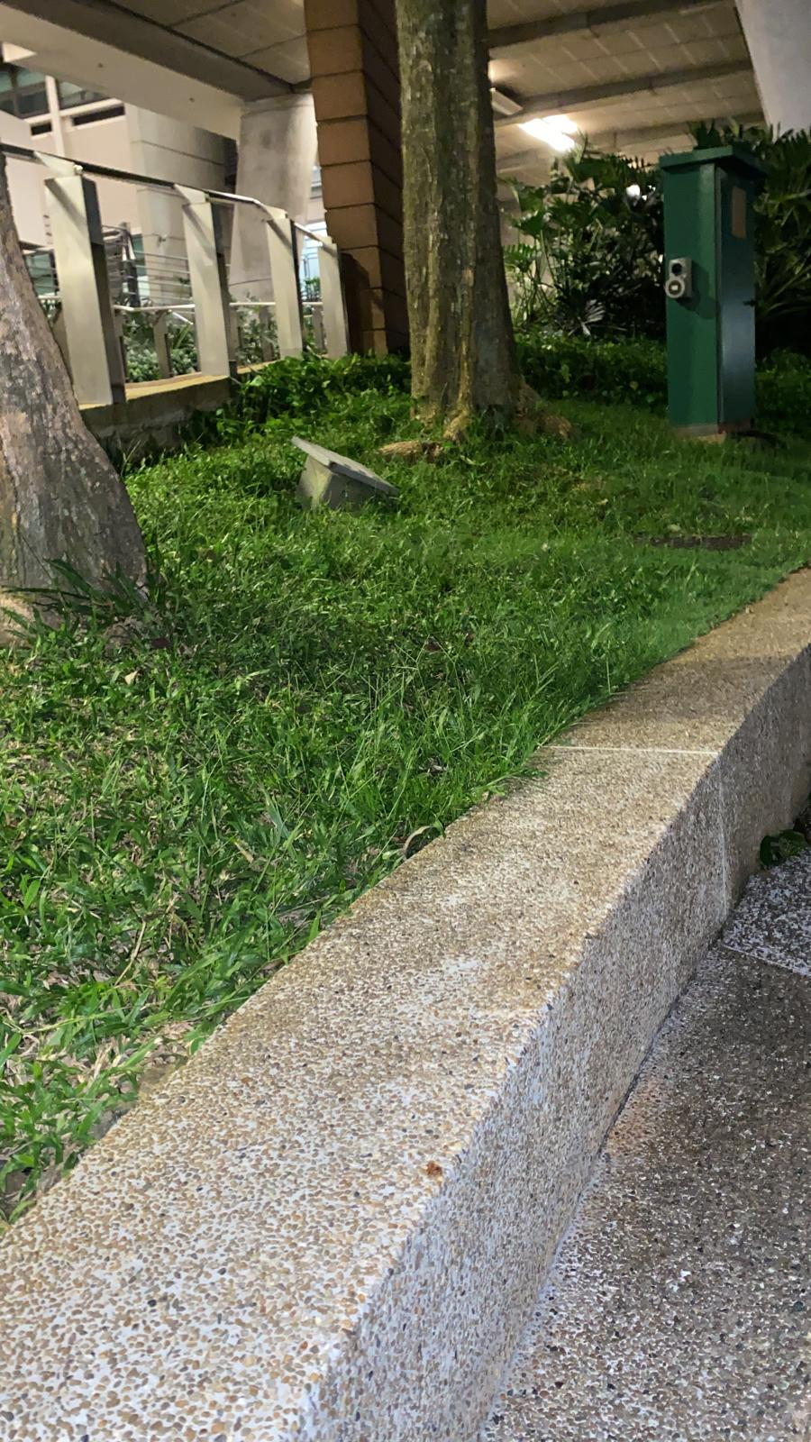

Fig. 3: Wheeled-Inaccessible Grass Patch

Furthermore, many areas where grass-cutting is needed are not necessarily even ground, mandating a stable platform which can still traverse such obstacles. Thus, a four-legged design was chosen to ensure stability, with the possibility of a six-legged design being considered as well. As development of robot platforms already has significant traction, research, and funding, the focus of this project will be on the design and control of the arm itself as well as any additional systems that are required for it to function as intended.

To facilitate this, a readily available four-legged robot, the Unitree Robotics AlienGo, was chosen to be the design platform. A picture of this robot is shown below in Figure 4. This robot was chosen for two primary reasons: one being the current availability for development, and the second being its small stature. Although larger alternatives with greater payload and freedom of movement were considered, they were deemed too intimidating in their size for public use, and too expensive for practical deployment.

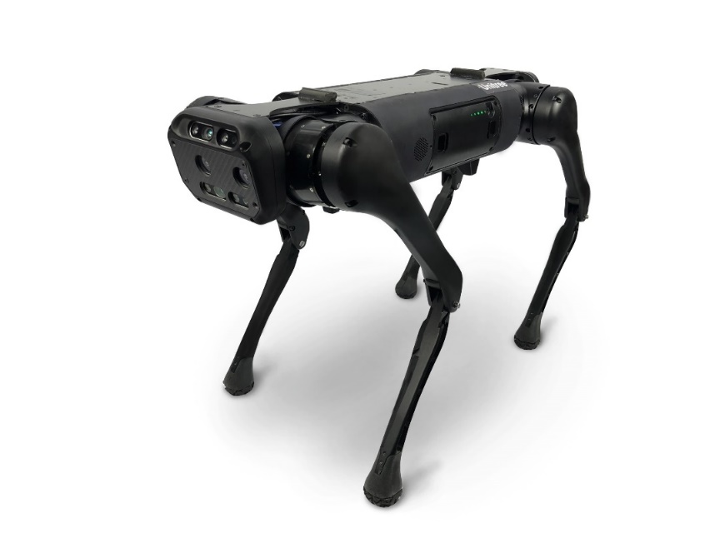

Fig. 4: Unitree Robotics AlienGo [8]

However, the major limitations of the AlienGo are also due to its small size: it is only rated for 7 kilograms of maximum payload weight according to the manufacturer, and frequently suffers from balancing issues when weight is placed off-centre. These two limitations are form the primary issues around which the robotic arm design, discussed further in the scope below, is formed around. Further technical details and specifications of the AlienGo robot are provided in Appendix A.

## 1.2. Scope of Project

As a result of the previously mentioned limitations of the AlienGo robot, a custom arm for the sole purpose of this research project is to be designed. This arm must fulfil the following criteria:

* A total weight not exceeding 5 kilograms, to account for any additional equipment such as sensors or batteries.
* 4 Degrees of Freedom (DOF), particularly 2 at the shoulder joint and 2 at the wrist joint.
* A concentration of arm weight equal to at minimum 75% on the shoulder area, to reduce balancing torque issues on the platform.
* As far as possible, vibrational damping of the payload to reduce interference.

In addition to the arm system, various supporting elements, such as the electrical wiring, computer elements, and control software must be designed. The electrical system must adhere to the following requirements:

* At least 18V of power supply.
* Switches for individual motors (a by-product of the Steadywin Motors creating a power surge when turned on, explained further in Section 3.2)
* Slot for external battery due to limited capacity on the AlienGo robot.

Similarly, the control software for the arm should be able to fulfil the following requirements:

* Full joystick control for all 4 DOF.
* A toggleable automated sweeping motion for use on flat grassy surfaces.
* Full integration with Robot Operating System (ROS) as an operational scheme.

These requirements form the basis for the project’s development focus.

# 2. Literature Review

As this project focuses primarily on the design of a mechanical system as well as the control of that system, this literature review focuses on currently existing robotic arms in use, as well as currently existing legged robot platforms.

## 2.1. Low-Cost Robotic Arms

High-performance robot arms are common in industrial applications, and use powerful motors that are able to generate high amounts of torque. This is excessive for an application such as grass-cutting, and thus this section focuses on reviewing current measures to reduce cost and weight while generating sufficient performance.

Small scale and relatively simple robot arms such as the one designed by Elfasakhany in 2011 can still maintain accurate, precise movement while containing an end-effector of choice [9]. Due to modern software and interface technologies, both automated and manual control remain viable options as shown. A teleoperable robotic arm design is also shown by Rogers in 2009, which similarly uses hobby-grade parts while operating a camera end-effector [10].

In their 2019 paper, Bugday and Karali focus on comparing the benefits of reducing redundant weight in industrial-grade robotic arms [11]. Similarly, by applying novel features such as counterbalancing as done by Kim and Song in 2013, weight and thus required torque outputs can be kept low [12]. In 2015, Kim, Min, and Song also studied the use of bevel gears as a comparison to wire-based mechanisms, in order to further reduce the torque required to support the robot’s mass [13].

Cable-driven systems such as the one developed in 2014 by Renda et al. for soft robot arms are also possible as they allow for motors to be placed further away from the joint axes [14]. For a hard robot arm they would be limited to use in specific joints such as the manipulator itself as shown by Lim et al. in 2013 [15]. Advanced designs that utilize only cable-driven joints are also possible such as done by NAVER LABS [16], but these pose reliability issues as stated earlier by Kim, Min, and Song [13]. Mao and Agrawal in 2012 also pointed out the inability for a cable-driven system to ‘push’ a joint, thus adding additional hurdles to adopting such systems [17].

## 2.2. Legged Robot Platforms

Perhaps the most well-known recent legged robot platform is the Mini Cheetah designed by Katz, Carlo, and Kim in 2019 [18]. Another example is the Stanford Doggo designed by Kau et al. in 2019, stated to perform with exceptional vertical agility [19]. These platforms showcase the capabilities of a four-legged design while still being low-cost and highly controllable. However, due to their small size, they have limited payload capacity and are not suitable for applications that would require a robot arm.

Comparatively, larger designs such as the Boston Dynamics BigDog are rugged and powerful, but excessively so for a small-scale application such as grass-cutting [20]. Thus, a more intermediate design such as the ANYbotics ANYmal four-legged robot were considered [21].

Additionally, six-legged robots are also feasible for use in a grass-cutting operation, although many are inspired by insects and are extremely small in design, such as the AntBot and Little Crabster [22] [23]. An example of a six-legged robot with approximately accurate capabilities would be LAURON V, although it too approaches the range of being excessively powerful similar to BigDog [24].

As commercially available robots were a logical choice in the absence of developing a purpose-built robot platform, the Unitree Robotics AlienGo was picked due to its availability.

# 3. Development

The development of this project can be split into three main sections depending on primary content: Mechanical, Electrical, and Software. Despite this apparent separation, development on each section occurred in parallel.

## 3.1. Mechanical Design

Two primary designs were made for the mechanical structure of the arm, the second design the result of numerous iterations based upon lessons learnt from the first design. Between these two main designs, a number of iterations were also made. Figure 5 below showcases the largest variations between the first and final designs.

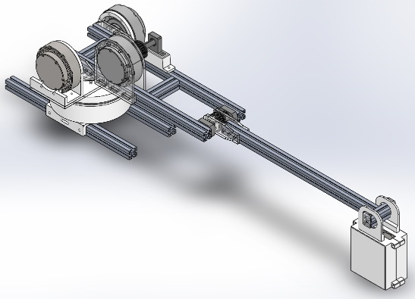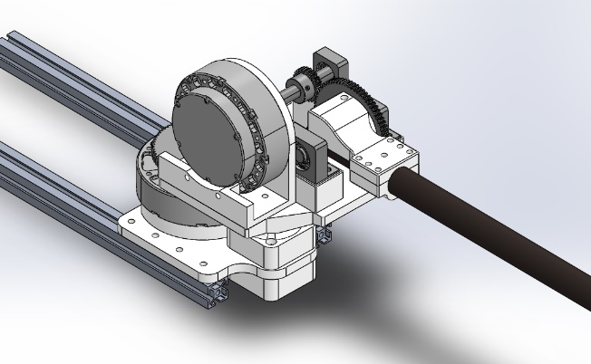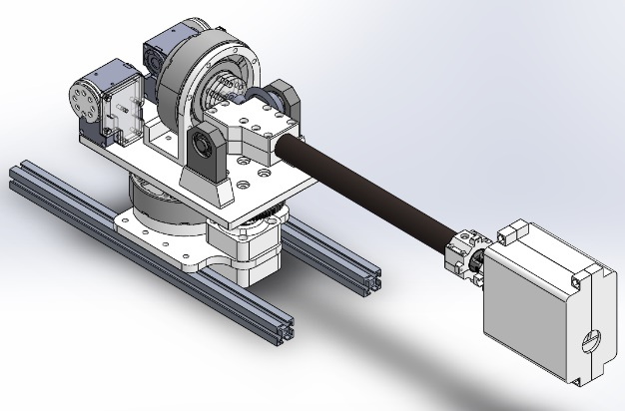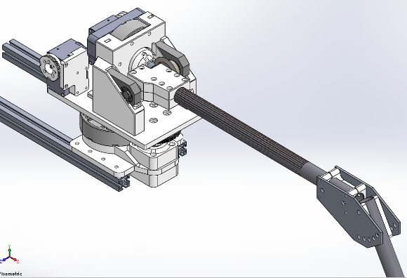

Fig. 5: Primary Design Iterations between First and Final Designs

Prior to the prototyping of the first design, a number of theoretical calculations were required in order to set the groundwork for the required parts.

### 3.1.1. First Design - Theoretical Calculations

As part of the first design stage, theoretical calculations were needed in order to understand the physical requirements, such as motor torque, which would affect the choice of motors from an available list. A motor feasibility calculation using the equation and the respective free body diagram is shown in Equation 1 and Figure 6 below respectively. This equation calculates the required torque Tn for the motor placed at the shoulder position on the far left. A breakdown of the derivation of Equation 1 is shown in Appendix B.

$T_{n}= \left[\frac{{(m}_{l}+m_{m})}{2}n^{2}+\left(m_{p}-\frac{m_{m}}{2} \right)n\right]gl$ (Equation 1)

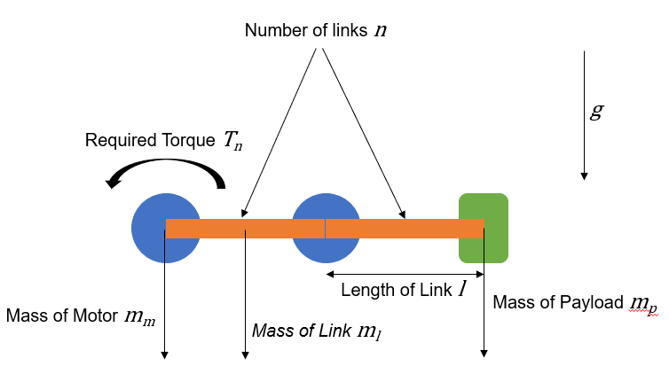

Fig. 6: Free-Body Diagram for Motor Feasibility Calculation

A table of the feasibility calculations is shown in Appendix C, considering the different number of links (assumed to use aluminium extrusion profiles), the mass of individual components, and their locations along the links in order to estimate the required motor torque at the shoulder, the revolute joint most likely to require the highest torque. Additionally, a safety factor of 1.5 was applied to account for the various estimations which did not include the weight of any additional components such as mounting points.

From this calculation, it was found that two motors would be needed at the shoulder joint for pitch control in the absence of other torque-altering modifications. With the Steadywin V3 motors as described in the Appendix 1 calculation table being readily available, they were chosen as the basis for the first design, forming the core of the first prototype.

### 3.1.2. First Design - Prototype

The first design is a direct result of the calculations in Section 2.1.1, and contains 2 DOF at the shoulder, 1 DOF at the elbow, and 1 unpowered DOF at the wrist that is gravity-stabilized. The CAD of this design is shown below in Figure 7, with the prototype mounted on the robot in Figure 8 below.

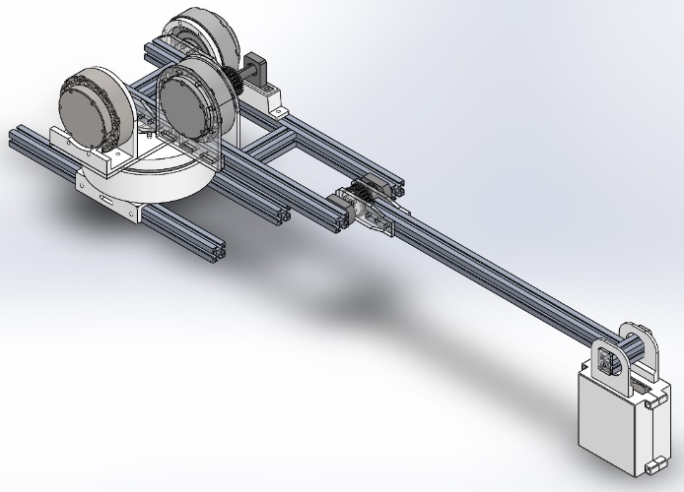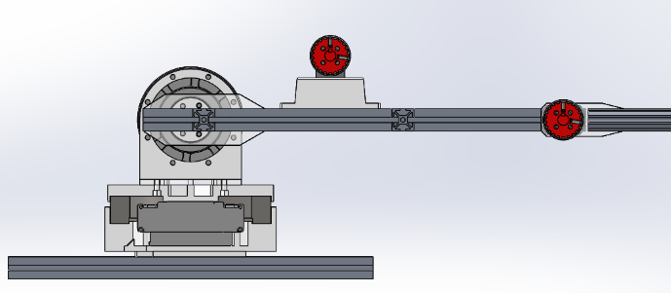

Fig. 7: Isometric and Sectioned CAD of the First Design

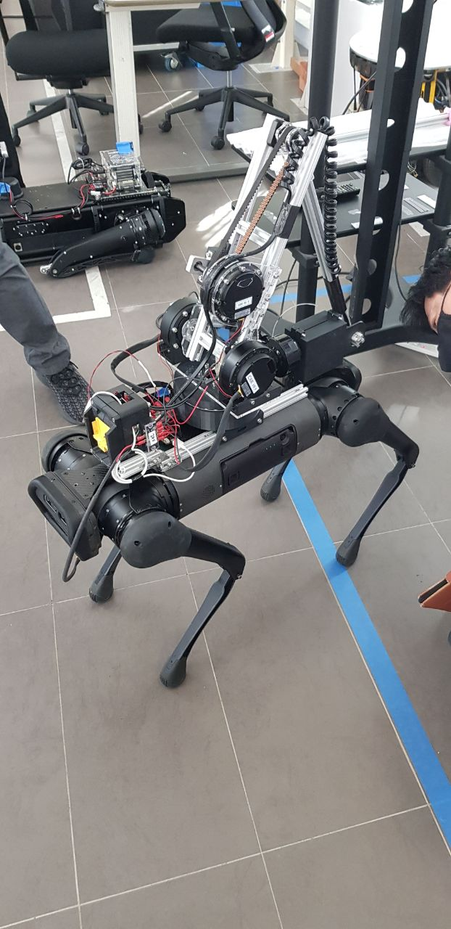

Fig. 8: First Design Prototype mounted on AlienGo Robot

This prototype utilizes four Steadywin V3 motors, a belt-and-pulley system for the elbow, and a commercial-off-the-shelf grass-cutter motor, with the wrist joint left unpowered as a passive damper against the vibrational interference from the grass-cutter operation.

### 3.1.3. First Design - Analysis

Inadequacies in the first design were identified through testing of the robot platform. Namely, the high overall weight of around 6.5 kg and the lack of counterbalancing at the shoulder resulted in high motor loads. Much of this weight can be attributed to the large thrust bearing surrounding the shoulder yaw motor, intended to reduce the perpendicular moments on said motor. The identified issues and their resolutions are listed below in Table 1.

Table I: Problem-Solution Analysis for First Design Prototype

|  |  |
| --- | --- |
| First Design Issue | Second Design Solution |
| Weight of 6.5kg exceeds primary mechanical requirement. | Removal of heavy bearing components, reduction of number of heavy Steadywin motors, switching of aluminium links to carbon fibre rods. |
| A single shoulder pitch motor generates insufficient torque. | Use of a 3:1 gear ratio allows for a single motor to be used rather than two. |
| Single shoulder pitch motor requires large spur gears that are very heavy. | Usage of bevel gears instead also allows for better centralization of the motor’s weight. |
| Height of arm system contributes significantly to robot platform imbalance. | Offset of shoulder yaw by using a vertical drive shaft with a 1:1 gear ratio. |
| Offset of shoulder yaw may cause gear misalignment due to perpendicular moments on the vertical drive shaft. | Inclusion of two radial bearings and one thrust bearing to prevent misalignment issues. Calculations shown in Equation 2. |
| Lack of wrist control for grass-cutting near obstacles and on uneven surfaces. | Use of cable-driven wrist using Dynamixel motors. |
| Lack of counterbalancing for the arm system causes weight distribution issues on the robot platform. | Utilizing the Dynamixel motors that drive the wrist as counterweights on the shoulder. |
| Difficulty in accessing critical components such as motors and electrical connections. | Trimming of structurally-unimportant pieces to increase accessible areas while simultaneously decreasing total weight. |
| Complicated and messy wiring leads to frequent cable entanglements and difficulty in making adjustments. | Addition of an electronics box which will house the battery system, microcontrollers, and switchboard. |

These design changes lead to the second overall design, which forms the current prototype described in the next section.

### 3.1.4. Second Design – Theoretical Calculations

By using an offset transmission for the shoulder yaw motor, the possibility of gear misalignment poses an operational hazard. Gear slippage will not only impair the function of the robot arm, but damage the gears over time. Thus, by adding two radial bearings as stabilizers along this vertical shaft, perpendicular moments can be accounted for and the shaft can remain aligned with the motor axis. To assess the feasibility of this design, torque calculations for these two bearings had to be done.

The torque experienced by the bearings is similar to the motor yaw torque experienced in Equation 1, but with additional inclusion of offset mases and a possible counterweight. This new equation is presented below in Equation 2, with the relevant free-body diagram shown in Figure 9. The resultant torque is multiplied by 2 to account for the two radial bearings which are sharing load.

${2T}_{b}= \left[f(m_{f}+2l\left(m_{l}+m_{p}\right))-rm_{r}\right]g$ (Equation 2)

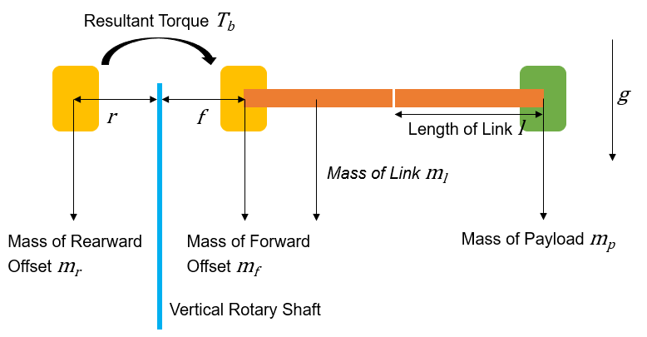

Fig. 9: Free-Body Diagram for Bearing Torque Calculation

The calculated resultant Torque *Tb* was found to be 1.01 Nm. For the 6900 radial bearing intended for use, it was found to have a static load rating of 1.27 kN [25]. With this setup, the bearing was calculated to have a static torque rating of 228.6 kN and thus a safety factor of 226, which is far more than sufficient for this application.

Additionally, the cable-driven wrist system required a theoretical torque calculation as well in order for a suitable motor to be chosen. The required torque can be calculated from the distance between the centre of mass of the payload and the pivot point of the universal joint, multiplied by the weight of the payload. This equation is shown below in Equation 3 and the related free-body diagram shown in Figure 10.

$T_{c}= dm_{p}g$ (Equation 3)

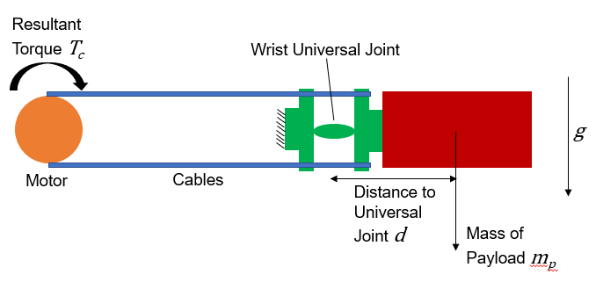

Fig. 10: Free-Body Diagram for Wrist Torque Calculation

From Equation 3, using a payload mass of 0.75kg and a distance of 0.08m, a torque requirement of 0.5886 Nm was calculated. Even with a safety factor of 3 to account for friction due to the cables and the universal joint, it was found that a Dynamixel XM540 with a 2 Nm sustained torque output would be sufficient while remaining small and relatively lightweight.

### 3.1.5. Second Design – Prototype

Utilizing the solutions devised in Table 2 in Section 2.1.3, a second prototype was developed. In addition to these solutions, a fixed but manually adjustable elbow joint replaced the belt-and-pulley system from the first design. Overall weight was thus reduced to around 5kg, allowing for additional computer and sensor equipment to be mounted. The CAD of this design is shown below in Figure 11, with the prototype on the robot in Figure 12 below.

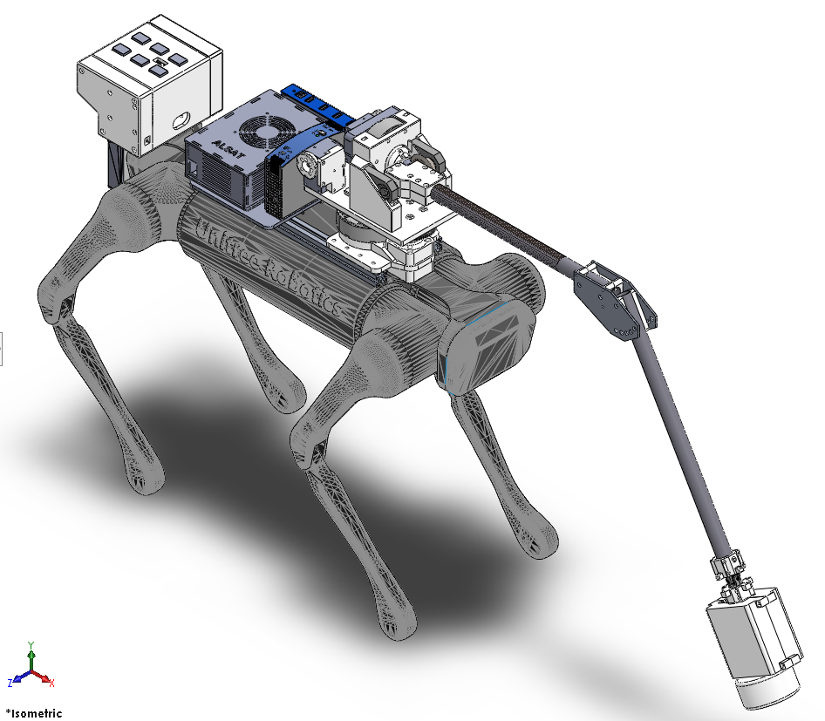

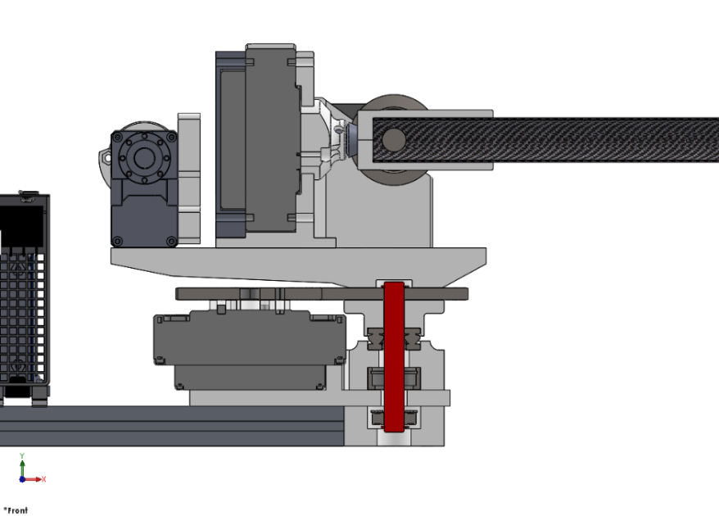

Fig. 11: Isometric and Sectioned CAD of the Second Design

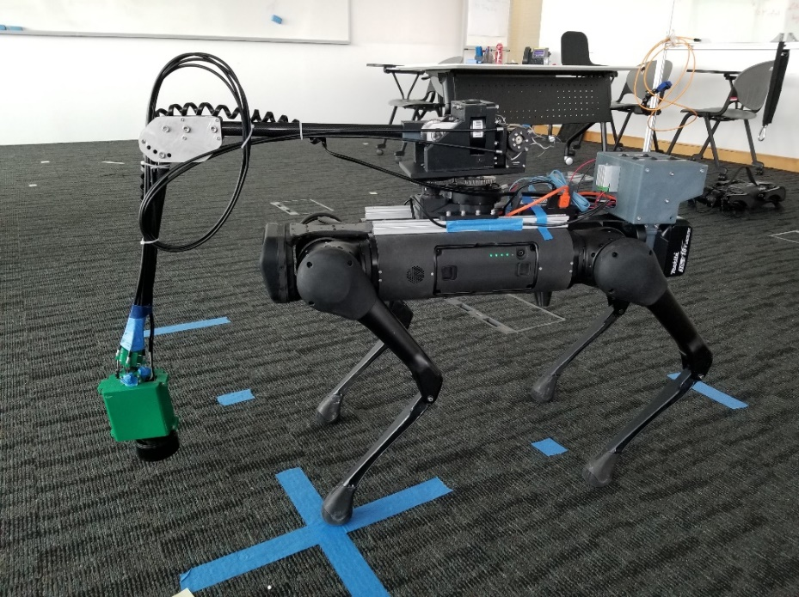

Fig. 12: Second Design Prototype Mounted on AlienGo Robot

### 3.1.6. Second Design – Structure

The structure of the finalized prototype utilized a mixture of 3D printed parts, laser-cut acrylic sheets, and manufactured parts ordered from Misumi, a mechanical components manufacturer and supplier. The design relied heavily on 3D printed parts as it was foreseen that many adjustments would need to be made depending on changing equipment and requirements.

The 3D printed parts consisted mainly of PLA or ABS plastic printed using Fused Deposition Modelling (FDM) in a range between 50 and 70% fill. Some structurally integral components such as the main base plate were printed at a 100% fill instead to strengthen their integrity. The FDM technique is the most common method of 3D printing and proves effective for prototyped parts such as these where tolerance can be sacrificed for printing speed.

A key issue when designing the parts for 3D printing was their directional qualities, as many parts had to sustain loads from specific directions. In addition to this, the parts also had to consider printability, as support structures had to be removed primarily by hand and thus hollow areas within parts must be made accessible.

Where necessary, manufactured parts were also incorporated into the design. Made of stainless steel or aluminium, these parts were used where structural stresses would be the highest, such as the yaw and pitch shafts at the shoulder and the transmission gears. With the exception of the motors, these parts form the bulk of the weight of the arm and thus had to be mainly located closer to the central structure to reduce balancing issues.

### 3.1.7. Second Design – Cable-Driven Wrist

The cable-driven wrist design was intended to provide the wrist joint with 2 DOF without increasing the weight of the arm structure, and thus helping to alleviate the shoulder pitch motor. Two Dynamixel XM540 motors were chosen based on the calculations done in Equation 3, with tensioned bicycle cables and their sheaths providing the linkage between the motors and the wrist joint. A CAD of the wrist joint itself is shown below in Figure 13.

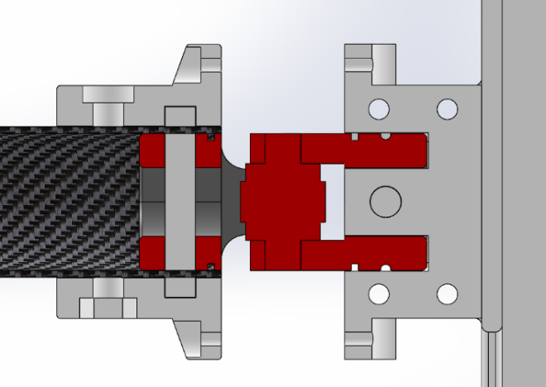

Fig. 13: Sectioned CAD of the Wrist Design

As can be seen from Figure 12, the manufactured universal joint is held in place by pins on both sides, the left side linking it to the arm structure and the right side linking it to the payload. The cable sheathes terminate on the arm side of the joint, while the cables themselves terminate at the payload side, providing a length of 9 mm by a breadth of 25 mm in which the joint can tilt in any of the two DOFs. This length and breadth were calculated to create two separate two-dimensional angular ranges of 83 degrees each.

### 3.1.8. Second Design – Finite Element Analysis

Using the Solidworks Finite Element Analysis Simulation Add-In, a static and frequency analysis of the system could be generated. However, due to numerical complexity, analysis of large numbers of components at once was deemed unfeasible. Thus, two general parts that were identified to be the most likely to fail were selected. Primarily, this was because these parts were deemed to be carrying the most load or torque with a relatively little amount of surrounding support structure.

#### 3.1.8.1. Pitch Motor and Bearing Mount

The first of these parts is the pitch axis stand, which holds the Steadywin motor responsible for pitching the arm as well as the two bearings that hold the pitch torque shaft. The location of this piece is highlighted in the arm structure in Figure D1 in Appendix D.

With this piece, it was clear that the bulk of the torque would be acting on the areas that hold the two bearing blocks, as well as the structure of the motor. The static analysis for this piece was thus done using a worst-case scenario, with the entire weight of the rest of the arm structure placed onto the surfaces that house the two bearings – a total static force of 15.4 N. In addition, this weight was also placed pushing back onto the surfaces that house the Steadywin motor. The results of the static analysis are shown below in Figure 14.

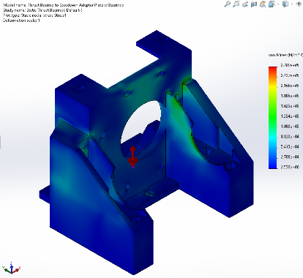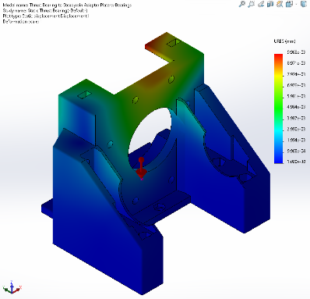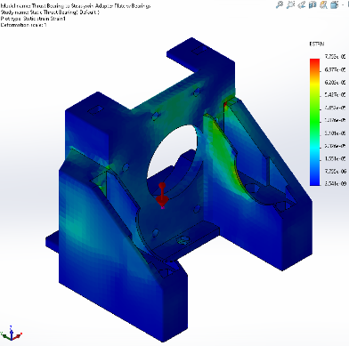

Fig. 14: From left to right: Stress Analysis, Displacement Analysis, and Strain Analysis of Pitch Motor and Bearing Mount

This static analysis shows that despite the high forces in the extreme worst-case scenario as presented here, the plate is rigid enough that very little deformation occurs, in the order of magnitude of 10-3 mm. This means that the part as designed is incredibly strong and is highly unlikely to fail. Comparing the highest experienced von Mises stress of 0.2708 MPa to the average Ultimate Tensile Strength of ABS plastic of 40.7 MPa, it can be seen that there is a safety factor of around 150 [26].

Similarly, a vibration analysis was done on the same part, with the lowest frequency result of this analysis shown below in Figure 15 and the full results shown in Figure D2 to D5 in Appendix D.

This vibration analysis shows that the resonant frequency experienced by the component is at 708 Hz, which satisfies the octave rule by being at least 1 octave higher than the surrounding mechanical components.

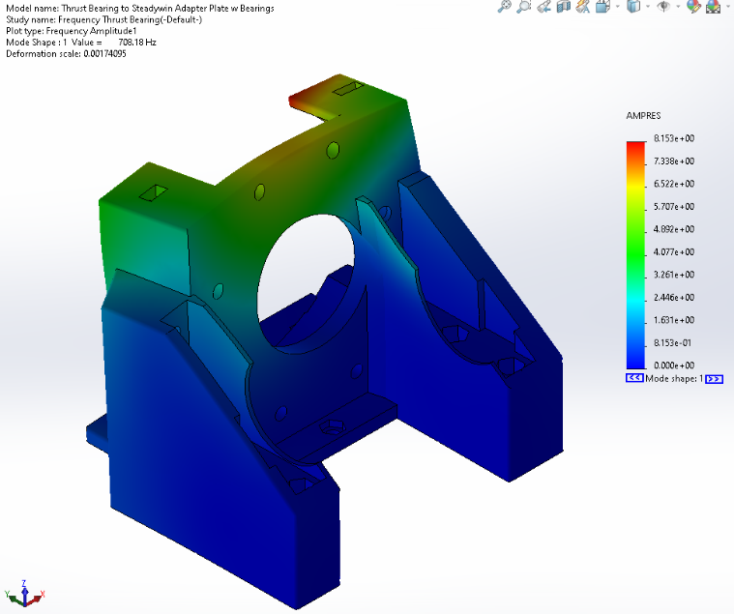

Fig. 15: Frequency Analysis of Pitch Motor and Bearing Mount (1)

#### 3.1.8.2. Grass-Cutter Wrist Mount

The second selected part is the grass-cutting motor holder at the wrist, specifically, the components after the universal joint. This piece holds a significant amount of weight while being made of PLA plastic, and may be required to hold it at a horizontal angle where the strain on the relatively small connection area. The location of these components is highlighted in the wrist structure in Figure E1 in Appendix E.

For this piece, the largest amount of static force would be the weight of the grass-cutting motor on the internal structure of the mounting box. By placing a weight inside the box, the stress, strain, and resulting displacement of the mounting box can be determined. The results of the worst-case static analysis where the mounting box is fully extended horizontally are shown below in Figure 16.

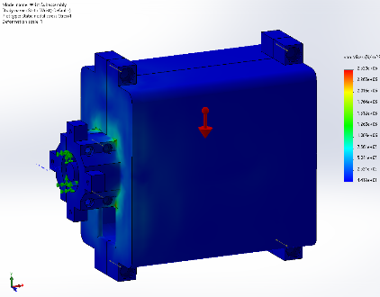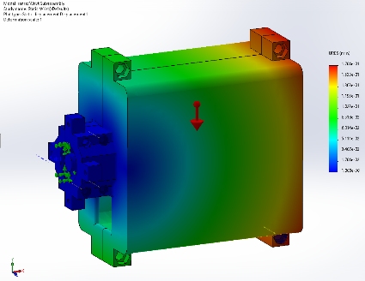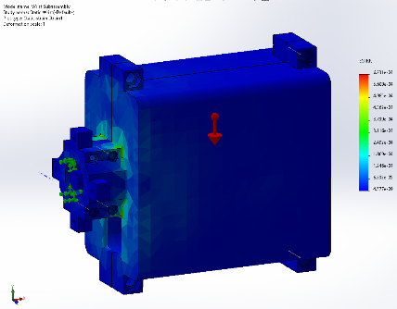

Fig. 16: From left to right: Stress Analysis, Displacement Analysis, and Strain Analysis of Grass-Cutter Wrist Mount

This static analysis shows that the greatest stress and strain is experienced by the connection point between the universal joint connector and the motor mount box itself, with the greatest experienced von Mises stress of 2.52 MPa versus the Ultimate Tensile Strength of PLA plastic of 65.4 MPa. This means there is a safety factor of 25.95 in the worst-case scenario [27].

Additionally, the greatest displacement is experienced by the furthest point away from this connection point. It should be noted that this displacement is incredibly small, with the greatest displacement experienced at 0.1704mm. This can be considered small enough that the structural integrity of the wrist is not highly affected by even the worst-case scenario.

Similarly, a vibration analysis was done on the same part. However, this analysis was of particular importance due to the proximity to the grass-cutting motor, which operates at around 7800 RPM, or around 130 Hz [28]. This means that frequencies around 130 Hz can be relatively expected during the operation of the grass-cutting motor. The lowest frequency result of this analysis is shown below in Figure 17, with the full results shown in Figure E2 to E5 in Appendix E.

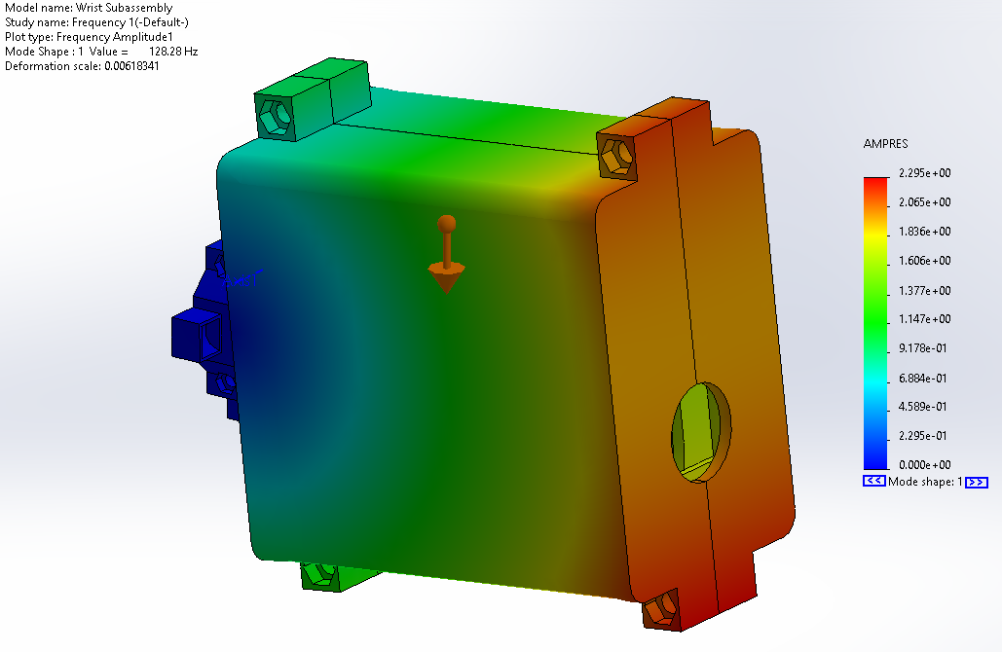

Fig. 17: Frequency Analysis of Grass-Cutter Wrist Mount (1)

This vibration analysis shows that, at a frequency of 128.28 Hz, there is significant amplitude in the selected part. It can be noted that, due to the grass-cutting motor operating at a frequency of 130 Hz, this is dangerously close to the calculated natural frequency of 128.28 Hz and thus does not satisfy the octave rule.

The importance of this analysis is that damping of the part itself is highly required to minimize this possible resonance between the operation of the grass-cutting motor and the mounting. This is done on the practical design due to the existence of universal joint which absorbs a considerable amount of vibrational frequency, as well as rubber inserts between the motor and the mounting itself. As the frequency analysis conducted here has no damping whatsoever, the results are also greatly exaggerated compared to the real-life counterpart.

Finally, a drop test was conducted with the grass-cutter wrist mount as it was identified as the component most likely to impact the floor. With a drop height of 1 meter, the results are shown below in Figure 18.

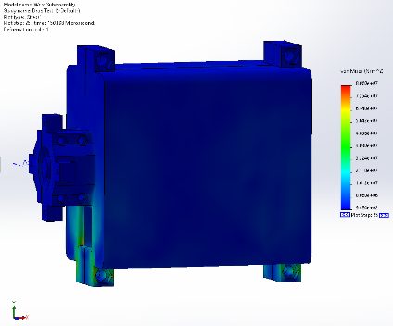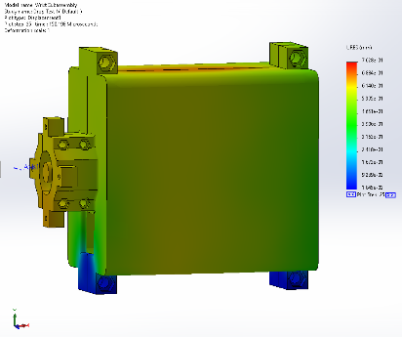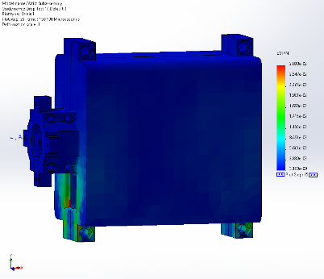

Fig. 18: From left to right: Stress Analysis, Displacement Analysis, and Strain Analysis of Grass-Cutter Wrist Mount Drop Test

From the drop test above, it can be seen that the structure of the wrist mount experiences generally low stress except for a very specific area near the bottom region. Comparing the median experienced von Mises stress of 40.3 MPa to the Ultimate Tensile Strength of PLA plastic of 65.4 MPa, it can be seen that there is a safety factor of 1.62 despite the high drop height, although a very small region of the system will likely experience failure and cracking [27].

## 3.2. Electrical Design

The electrical system remained relatively similar between the first and second mechanical designs, with only the container shells having changed as well as the inclusion of the Dynamixel motors within the circuitry. The full circuit diagram for the second design is shown below in Figure 19.

Of note is that all five motors are powered by the 18V Makita battery adapted for use from the handheld grass-cutter. This 18V supply is sufficient for the two Steadywin motors but is too high voltage for the Dynamixels and had to be stepped down to 12V using a transformer before reaching the U2D2 Power Hub Board.

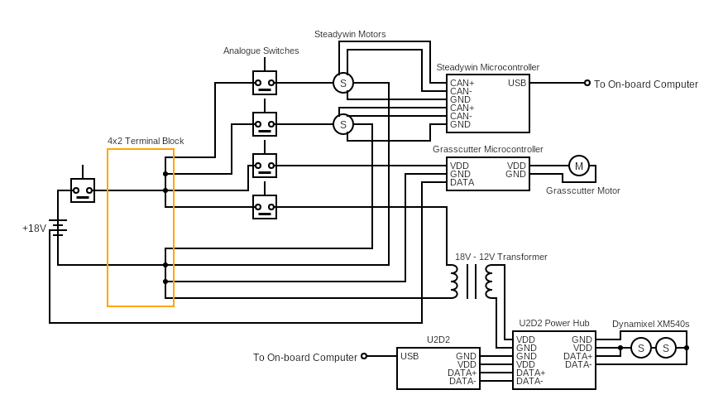

Fig. 19: Circuit Diagram of Components

An analogue switch was also connected to each motor due to the tendency for the Steadywin motors to spike in power upon their activation. Frequently, these motors would draw up to 10 Amperes of current when powered on, causing other integrated circuits to be damaged if all were activated simultaneously. The possibility of using a high-resistance current limiter was also considered but ultimately deemed unnecessary due to the increased weight and bulk. Instead, by powering on each switch in order, the power surge could be limited specifically to the affected motor without risking any other components.

Wires of 16 AWG were used in all power systems except for the output of the U2D2 Power Hub Board, due to the large current draw from the Steadywin motors and the grass-cutter motor. To increase the flexibility of the design and allow for wires to be easily disconnected and reconnected, Molex Mini-Fit connectors were used as they are rated for up to 13 Amperes as well as 16 AWG [29].

With the exception of the motors and external connections, the electrical components were designed to fit in a single electronics box at the rear of the AlienGo robot to minimize exposed wiring.

## 3.3. Software Design

Along with the hardware development, control systems were also required for the robot to be able to perform its intended function. ROS is a robotics middleware that is widely used as an industry-standard baseline for robot development. This framework allows for easy and relatively efficient integration of different pieces of hardware which are individually coded differently and thus would otherwise be incompatible. ROS solves these problems by creating a communication framework between designated nodes, allowing them to publish messages to topics which are then subscribed to by other nodes. In essence, this means that each node can work independently from others as it only considers the code within its own isolated boundaries.

In order to streamline the full package, it was decided to develop it entirely within the ROS system that would also contain navigation and sensor software for the robot. Three primary components were identified as requiring nodes within the ROS integration: the Steadywin motors, the Dynamixel motors, and the joystick which would provide input to the motors. A control diagram of the individual nodes, the topics they interact with, and the messages being sent between them is shown below in Figure 20. This diagram was edited from the ROS standard rqt_graph to include the rosservice commands that would not be normally displayed.

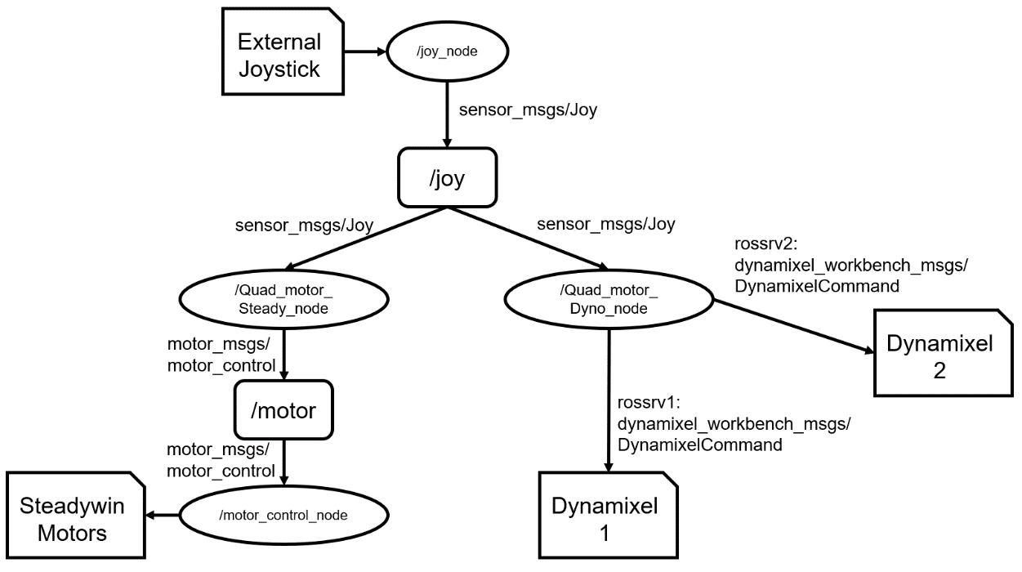

Fig. 20: ROS Control Diagram for Grass-Cutting Arm

Developing the software implementation as a practical concept also meant that implementing it within a simulator would provide an inaccurate demonstration of the platform. This was due to the inherent disconnect between the robot platform’s behaviour and the attached systems such as the arm. As the robot is a commercially-available one, a holistic integrated system must be designed to incorporate the internal components which control the robot’s balance, leg force, and so on, along with the external components which control the navigation planning and the arm motions. Without this integration, any simulations would not properly consider, for example, the effect that turning the arm would have on the balance compensation that the AlienGo’s legs would provide.

### 3.3.1. Steadywin Control Node

The node for the Steadywin motors subscribes to the “joy” topic which is published to by the joystick controller. This topic provides messages of the type sensor_msgs/Joy, which, whenever received, initiate a callback function that calculates the new goal position of each Steadywin motor. Then, the node publishes to the “motor” topic a message of type motor_msgs/motor_control, which is picked up by the motor controller to then move the motors toward those goal positions at the speed which was indicated. A snippet of the code that is responsible for publishing the motor_control messages is shown below in Figure 21.

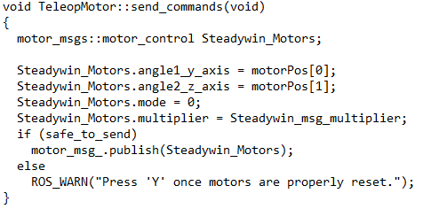

Fig. 21: A Snippet from /Quad_Motor_Steady_node which sends commands to the Steadywin Motors

This node contains the functions for the joystick manual control using a twin-stick controller. In addition, it also contains functions to change the motor speed, reset the motors to their zero position (designated when powering on each motor), and to toggle the motors into a sweeping motion.

The sweeping motion was identified as the widest swathe that could be cut by the robot without creating significant imbalance, and thus it is a slow and repeated movement of the grass-cutting arm.

### 3.3.2. Dynamixel Control Node

Similar to the Steadywin motor controller in design, the primary difference when sending commands to the Dynamixel motors is that they do not subscribe to any topics. Thus, commands had to be sent using the rosservice package. Instead of publishing to a topic, the control node calls the service by sending a request message, which in this case also contains the goal position to be sent to the motor. This then receives a reply which functions as a checksum to indicate a successful message sent. A snippet of the code where the service request is sent is shown below in Figure 22.

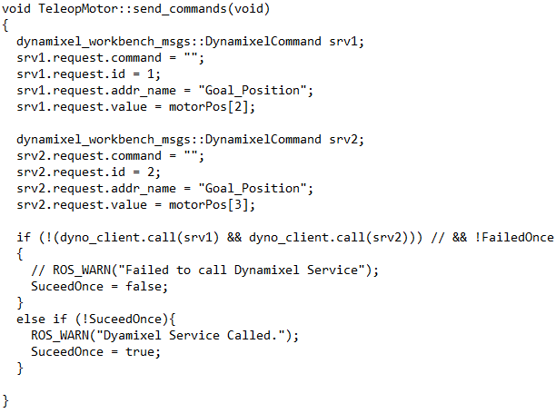

Fig. 22: A Snippet from /Quad_Motor_Dyno_node which sends commands to the Dynamixel Motors

While unorthodox, this method is functionally identical in practice to the publisher/subscriber format as the nodes and messages within this application remain simple enough that there is little to no interference between them.

# 4. Results

The full robot assembly and code was tested in primarily on flat ground with patches of grass placed at a distance. An ideal testing scenario would have been to perform testing on flat ground that was wholly covered in grass, but due to limitations in deployment access this was regarded as unfeasible. The conducted tests were split into two separate categories: balance tests for the robot and performance tests for the end-effector.

These two tests would then be used to generate the hard limitations of the robotic manipulator and thus its practical reachable workspace, as compared to the theoretical dexterous workspace which was designed earlier. This practical workspace forms the final working setup for the grass-cutting arm.

## 4.1. Balance Testing

In order to judge the effect of the grass-cutting arm on the balance of the AlienGo robot, it was determined to test the forward-backward drift as well as the lateral drift with the arm yaw at a range of determined angles.

The robot was first positioned at an origin, with the arm pre-positioned to the desired angle. By letting the robot step on the spot without any joystick inputs, the total drift of the robot over a certain time period can be determined. For this test, a 5-second period was allocated and the drift distance from the origin was measured. Figure 23 below shows an example result with the arm positioned at the 15-degree mark.

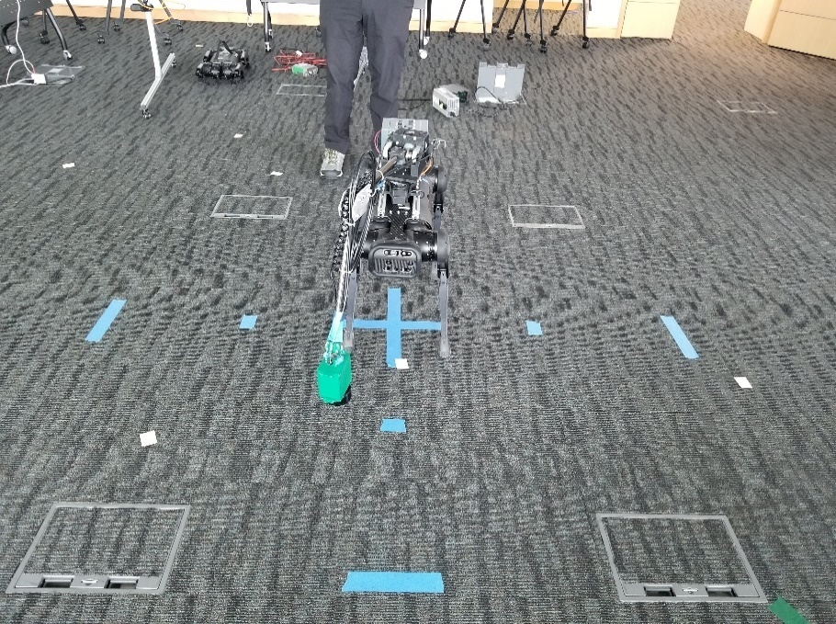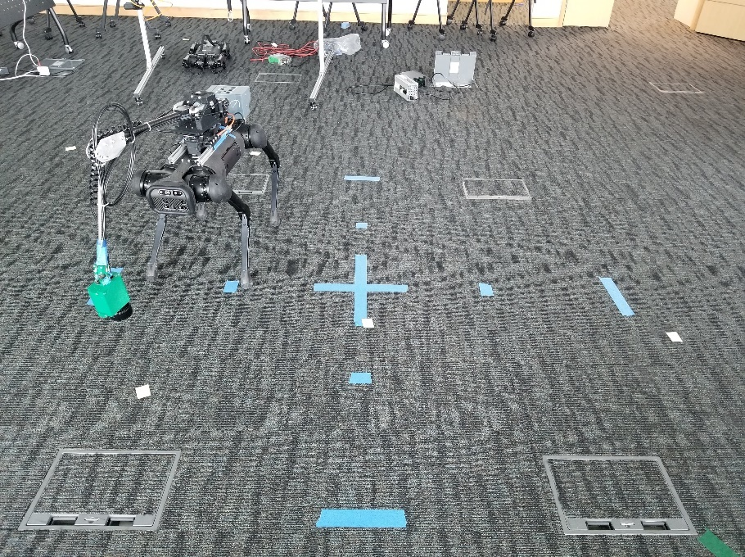

Fig. 23: Balance Testing with Arm at 15-degree Angle

Five different angles were tested: -30, -15, 0, 15, and 30 degrees. Although the yaw limit placed on the arm is designed to be 45 degrees, it was found that the balance of the robot was too negatively affected to be within acceptable safety limits and thus testing with such angles was not performed. The results of the test are shown below in Table 2, while further figures for the tested angles can be found in Appendix F.

Table II: Balance Testing Results

|  |  |  |  |  |  |  |
| --- | --- | --- | --- | --- | --- | --- |
| **Test Number** | **Axis Drift (m)** | **Angle** | | | | |
| **-30** | **-15** | **0** | **15** | **30** |
| **1** | **X-Axis** | -0.60 | -0.44 | 0.35 | 0.57 | 0.80 |
| **Y-Axis** | -0.10 | -0.15 | -0.04 | -0.28 | -0.35 |
| **2** | **X-Axis** | -0.74 | -0.50 | 0.34 | 0.58 | 0.79 |
| **Y-Axis** | -0.12 | -0.16 | -0.10 | -0.20 | -0.29 |
| **3** | **X-Axis** | -0.62 | -0.51 | 0.26 | 0.62 | 0.81 |
| **Y-Axis** | -0.13 | -0.20 | -0.11 | -0.23 | -0.31 |
| **4** | **X-Axis** | -0.72 | -0.46 | 0.28 | 0.49 | 0.71 |
| **Y-Axis** | -0.17 | -0.12 | -0.14 | -0.16 | -0.38 |
| **Average** | **X-Axis** | -0.67 | -0.48 | 0.31 | 0.57 | 0.78 |
| **Y-Axis** | -0.13 | -0.16 | -0.10 | -0.22 | -0.33 |

From these results, it can be determined that the AlienGo robot in its current state has a natural drift toward the right (positive X axis), with the drift being exacerbated when the arm is tilted in that direction. At the same time, pointing the arm toward the left (negative X axis) results in less overall drift. However, regardless of the current manipulator angle, the robot consistently drifts backward, most likely due to the electronics box having a significant effect on balance.

A test with the arm on sweep mode while the robot is in stepping mode was also conducted and can be found online[1].

## 4.2. Performance Testing

Two tests of the end-effector were conducted at two separate locations with different foliage types. While more tests were initially planned, the destructive nature of the end-effector does not facilitate repeated initiatives, and thus the performance review was conducted in two different but related situations that the setup should be able to tackle.

The first test utilized sparse leafy foliage at about 10 cm off the ground, with the intention of trimming the plant to just above ground level. This was done by raising the arm to the intended level first, then walking the AlienGo robot closer and activating the desired sweeping motion. The test was conducted using a long cutting blade of 12 cm in length to cut a wide swathe of plants at once. A picture of the system during the first performance test and a picture of a patch of foliage just cutting are shown below in Figure 24 and Figure 25 respectively. The complete video of one section of the test can also be found online[2].

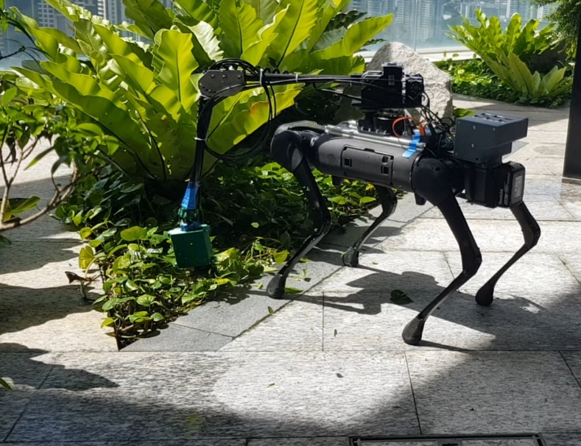

Fig. 24: First Performance Test

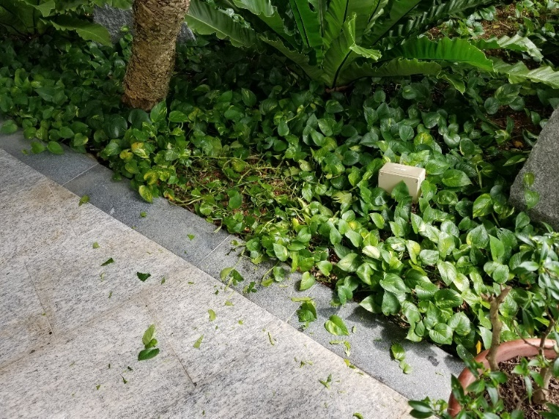

Fig. 25: Single Result of First Performance Test

This first test shows that for relatively light applications such as leafy foliage close to the ground, the grass-cutter motor is powerful enough to cut large swathes without difficulty. At the same time, it remains relatively controllable even without the integration of the robot control systems.

The second test utilized dense grassy foliage at about 15-20 cm off the ground, with the intention of trimming the top 25% of the plant. This test was conducted using a shorter cutting blade of 6 cm in length in order to reduce damage to the plants after the results of the first test. A picture of the second performance test and a picture of a patch of foliage just cutting are shown below in Figure 26 and Figure 27 respectively. The complete video of one section of the test can also be found online[3].

This test shows that the dense foliage is significantly more resistant to the grass-cutting motor in question, and that it will be difficult to utilize motors of weaker power due to possible inabilities at tackling such plants. Even with the current motor setup it is clear that the motor is less effective at cutting the plants than in the first performance test.

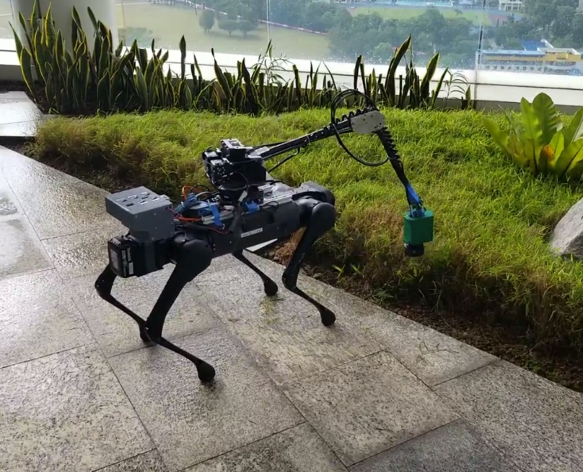

Fig. 26: Second Performance Test

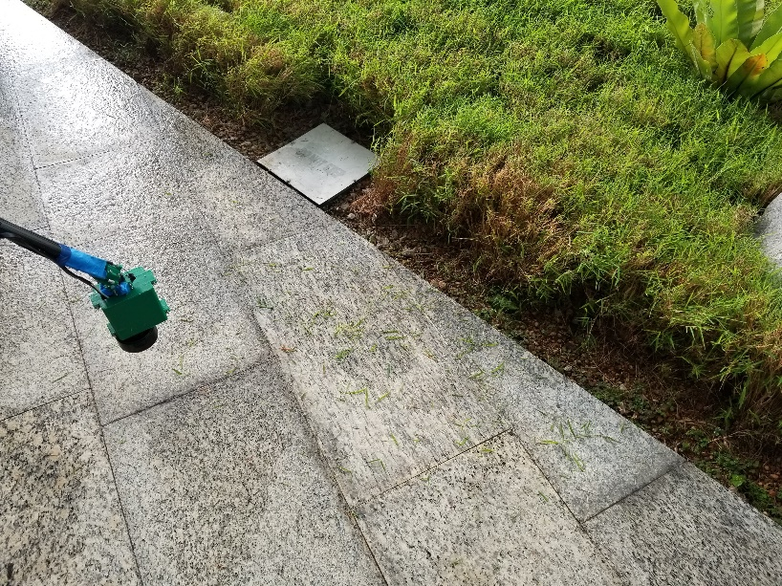

Fig. 27: Single Result of Second Performance Test

## 4.3. Miscellaneous Testing

Other components of the arm which were tested but not included in the two primary tests were the cable-driven wrist, the vibrational intensity of the grass-cutting motor, and the battery life duration of the external 18 V battery.

### 4.3.1. Cable-Driven Wrist Results

The cable-driven wrist, while effective at yawing and pitching the end-effector at the universal joint when fully tensioned, proved difficult to maintain due to a lack of idle tensioners. This meant that after about 4 or 5 cycles of operation, the cables would become un-tensioned and unable to operate the system. This is further aggravated by the tendency for the braided steel cable to bend at oblique angles under compressive force, then maintain its new shape. These two factors meant that the system was effective when manually tensioned but completely inoperable after a few uses.

However, due to the design of the universal joint and the end-effector, the wrist joint in its un-tensioned form would hang downward due to gravitational stabilisation, typically the most desired pointing angle. For this reason, the inoperability of the wrist joint was not seen as a hindrance to other testing and the operation of the grass-cutter as a whole.

### 4.3.2. Vibrational Intensity

The vibrational strength of the grass-cutter motor at the end-effector was dampened through the universal wrist joint due to the dynamic and compliant nature of the joint. This also meant that the significant frequencies caused by the operation of the motor would not cause damage to the 3D-printed components of the wrist mount. Extended operation of the motor also revealed that any fastened bolts and nuts were not negatively affected by the vibrations in a significant manner.

This is in direct comparison to Section 3.1.8. Finite Element Analysis where it was shown that the grass-cutter wrist mount’s resonance frequency was close to the operating frequency of the motor. As a result, it can be shown that the damping of the universal joint and the rubber inserts around the grass-cutting motor are effective in alleviating any damage that would be caused by the vibrational intensity.

### 4.3.3. Battery Life

The runtime of the AlienGo robot from a full battery charge without external equipment is approximately 2.5 hours while idle and resting, and approximately 1 hour and 15 minutes while standing or walking. With equipment, this standing time drops to around 45 minutes. Usage of the internal battery to power the grass-cutting arm further reduces this runtime to approximately 30 minutes before a low-power state is reached.

When the grass-cutting arm is powered by the external Makita 18V battery, the AlienGo internal battery maintains its 45-minute standing time while the grass-cutting arm itself has an operational uptime far exceeding that, in the range of 3-4 hours. However, with the grass-cutting motor switched on, the runtime drops to around 55 minutes from a full charge.

## 4.4. Manipulator Workspace

As a result of the previous balance and performance testing, it was deemed necessary to set further limitations onto the workspace of the grass-cutting arm to provide safety margins and improve controllability.

Although the arm by design is able to yaw a continuous 360 degrees, in practice this is limited more to 180 degrees due to electrical wiring entanglement. Furthermore, due to reasons highlighted in Section 3.1 earlier, it can be seen that tilting the arm more than 30 degrees to any one side dramatically increases the AlienGo robot’s lateral drift. Thus, it was determined that the range of yaw should be limited to 60 degrees.

In comparison, the pitch axis at the shoulder poses less of an issue to the robot’s stability, though raising the arm too high can still result in the overall centre of gravity being raised above the robot’s body frame. Thus, it was determined to limit the controllable pitch axis to 35 degrees above the horizontal reference, where the end-effector would be just below the reference plane. Similarly, as the end-effector would be digging into the ground if the pitch axis was pushed too low, the lower limit was determined to be 10 degrees below the horizontal reference, providing a final pitch range of 45 degrees.

For the cable-driven wrist, the maximum angle that could be achieved in any one direction was calculated to be 41.5 degrees. For safety reasons this was set to 39 degrees instead, forming a maximum pitch and yaw range of 78 degrees in total. Using these angle limitations, an estimation of the available reachable workspace was generated in Solidworks and is shown below in Figure 28.

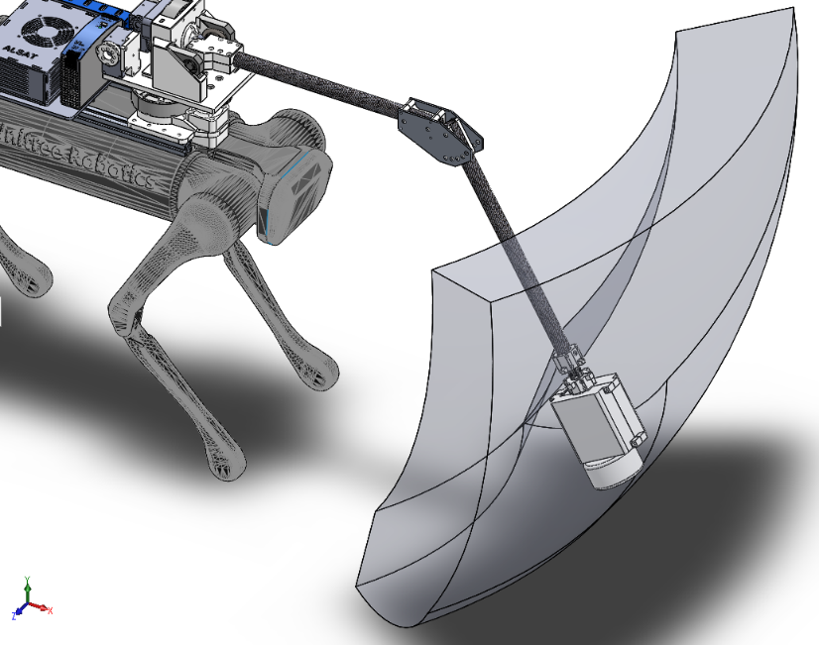

Fig. 28: Reachable Workspace of Grass-Cutting Arm

# 5. Analysis and Discussion

The balance test showcases the difficulty that the AlienGo robot has when operating with the full arm and electronics system. As the robot has no in-built drift compensation and it lacks any form of operational external localisation sensors, it performs poorly when the arm is tilted to any side while in stepping mode, and is only able to maintain its balance while in stationary standing mode. This issue, while lessened on the second design version compared to the first, remains a key problem that may be unsolvable while only considering hardware. A counterweight heavy enough to alleviate the robot’s natural drift will certainly be above the payload limitation of the AlienGo robot. Similarly, the components that currently occupy the greatest weight remain the motors themselves due to high torque requirements.

Compared to researched mechanisms that use advanced counterbalance systems [30] [12], the balance of the current arm design performs poorly from a purely mechanical standpoint. It is for these reasons that the integration of the control system of the robot along with the arm control will likely be necessary in fixing the balance issues of the AlienGo robot. This is further covered in Section 7: Future Developments.

In comparison, the performance of the grass-cutting arm is within acceptable bounds with a few exceptions. The grass-cutting implement performs well on less dense foliage types and will be well-suited to cutting grass and other types of low strength plants. Similarly, the ability to adjust the pitch at the shoulder as well as the pitch at the wrist allows for varying heights of grass to be cut to their desirable lengths while maintaining a uniform slicing height. Compared to modern autonomous grass-cutters that are wheeled and unable to adjust the elevation of the cutting implement significantly, this is a large advantage as the end-effector will be able to reach elevated surfaces or more finely control the height to be cut [4] [5] [6].

By using the external battery to power the additional motors that make up the arm and the end-effector, battery power on the robot is conserved which allows for a maximum continuous runtime of approximately 45 minutes while in standing or walking mode. While this is an improvement over the previous design which contained no external power source, it is lower in comparison to solar or hydrogen-powered automated grass-cutters that are being researched today [6] [5] [31].

Nevertheless, certain issues surrounding the performance of the arm design are evident. It can be noted from the tests that the yaw mechanism tends to sway significantly. This issue stems primarily from the Steadywin motor gain control, which if set higher can eliminate the back-and-forth swaying that moving the arm too quickly causes. However, increasing the gain also increases the risk that an impact or shock to the arm will cause the motor to overcompensate and be damaged from attempting to hold the instantaneous force. With a lower gain, the motor will retain a measure of compliance to forces that may otherwise damage the motor or other components, which is a desirable safety feature. The length and weight of the arm further compounds this issue due to the significant moment of inertia, and reducing either or both parameters may help to prevent such an issue.

Finally, the performance of the cable-driven wrist was less than desired due to the frequent manual intervention required to keep the system operational. While an idler would be difficult to implement due to the sheathed nature of the cable, on a more developed prototype the cable sheath can be split into multiple parts and an idler placed at a section of exposed cable. The cable can thus be kept tensioned at the cost of additional mechanical complexity to the system. This is a common solution to the tensioning problem, although more advanced state-of-the-art designs that utilize multiple motors to pull or release cables as needed exist [32]. As the cable-driven system introduces significant compliance while remaining highly controllable at the end-effector region such as in the NAVER LABS AMBIDEX arm, it continues to be a desirable option despite its current drawbacks [16].

# 6. Conclusions

The second design of the grass-cutting arm proved to be a significant improvement over the first prototype, with reduced weight and improved DOF control without compromising on the payload itself. This improved design, after testing, has shown that it is capable enough to be a functional system, however there remain many improvements that can be made to further advance its capabilities.

Firstly, the yaw mechanism requires further testing and improvements in software control to pinpoint the optimal gain value for use in this project. Secondly, further reductions in weight through optimisation of designed parts, particularly 3D-printed elements, will be helpful in alleviating the strain on the AlienGo robot. Thirdly, the cable-driven system for the wrist requires the addition of an idler system to keep the cables tensioned at all times. Finally, a full integration of the robot’s control system will be necessary in producing a smooth and efficient system, countering any balance issues and allowing the robot to operate in a stable manner.

Overall, the grass-cutting arm project has proven to be a success, with a system that is able to fulfil its basic functions of cutting grass at different levels and on flat surfaces, with the robot itself being able to cross slightly uneven terrain. Compared to modern systems, it trades off battery life for this capability, and with the listed improvements will be able to fill requirements that are not currently solved by commercially available systems.

# 7. Future Developments

A number of improvements that can be made to the current design are listed below, as well as some suggestions for how such an undertaking may be viably accomplished.

The yaw mechanism requires a finely-tuned gain structure and possibly mechanical reinforcements in order to reduce the shakiness of the arm. Tuning the gain structure is likely to be best done through trial and error of the system as a whole. Mechanically, the moment of inertia can be reduced by removing excessive weight and shortening the length of the arm. While reducing the arm length can only be done to a certain extent before the end-effector would no longer be able to reach the ground, reducing weight ties into the next point of improvement.

A reduction of weight can be done through two primary means: changing of material and changing of components. Changing the material of current components is unlikely to be helpful as they are already made mostly of plastic. While using metal pieces would increase lifespan, it would further increase weight to undesirable levels. Instead, changing the components themselves will be more suitable. For example, the yaw motor does not have to be as strong as the pitch motor as it does not hold as much torque, and can be downgraded from the current Steadywin motor which weighs about 0.5kg. The same can be done for parts such as the steel cables for the cable-driven wrist, and the heavy radial bearings used for the pitch joint.

The cable-driven wrist can be improved through the addition of idlers that will keep the cables passively tensioned through multiple uses. These idlers can be added to zones where the cable is left exposed through the sheath.

Finally, perhaps the most important improvement is the control software integration with the arm software, allowing for the robot balance to be tied to the current arm position and used to eliminate the drift of the robot. This may require external sensors such as LIDAR or GPS to further improve accuracy, or use of the robot’s onboard visual odometry. This is the improvement which will represent the largest increase in the robot’s operating stability.

# **8. References**

|  |  |
| --- | --- |
| [1] | N. A. Azmir, M. I. Ghazali, M. N. Yahya and M. H. Ali, “Hand-arm vibration disorder among grass-cutter workers in Malaysia,” *International Journal of Occupational Safety and Ergonomics,* vol. 22, no. 3, pp. 1-6, 2016. |
| [2] | T. H. Ismail, A. M. Amirah, Jan, R. Abdulllah and M. Ariff, “A Preliminary Study of Noise Exposure among Grass Cutting Workers in Malaysia,” *Procedia - Social and Behavioral Sciences,* vol. 91, pp. 661-672, 2013. |
| [3] | “Slope Stabilization at Fort Canning Park - Chartworth Enterprise,” Chartworth Enterprise, 2016. [Online]. Available: http://chartworth.sg/wp/index.php/bwg_gallery/slope-stabilization-at-fort-canning-park/. [Accessed 27 December 2020]. |
| [4] | A. D. Shah, S. J. Mujawar, R. P. Sutar and S. R. Prasad, “Solar Powered Intelligent Grass Cutter Robot,” *International Journal of Scientific Development and Research,* vol. 5, no. 4, pp. 229-234, 2020. |
| [5] | B. Ibrahim, V. S. Brahmaiah and P. Sharm, “Design of smart autonomous remote monitored solar powered lawnmower robot,” *MaterialsToday: Proceedings,* vol. 28, no. 4, pp. 2338-2344, 2020. |
| [6] | D. M. Khan, Z. Mumtaz, M. Saleem, Z. Ilyas, Q. Ma, S. Ghaffar and S. ullah, “Solar Powered Automatic Pattern Design Grass Cutting Robot System Using Arduino,” *Preprints,* 2019. |
| [7] | “2020 Husqvarna Automower 435x AWD Robotic Lawn Mower,” Autmow, [Online]. Available: https://www.autmow.com/store/p74/Automower-435x-AWD.html#/. [Accessed 18 December 2020]. |
| [8] | “Unitree - Aliengo,” UnitreeRobotics, [Online]. Available: https://www.unitree.com/products/aliengo/. [Accessed 19 December 2020]. |
| [9] | A. Elfasakhany, E. Yanez, K. Baylon and R. Salgado, “Design and Development of a Competitive Low-Cost Robot Arm with Four Degrees of Freedom,” *Modern Mechanical Engineering,* no. 1, pp. 47-55, 2011. |
| [10] | J. R. Rogers, “Low-cost teleoperable robotic arm,” *Mechatronics,* vol. 19, no. 5, pp. 774-779, 2009. |
| [11] | M. Bugday and M. Karali, “Design optimization of industrial robot arm to minimize redundant weight,” *Engineering Science and Technology, an International Journal,* vol. 22, no. 1, pp. 346-352, 2019. |
| [12] | H.-S. Kim and J.-B. Song, “Low-cost robot arm with 3-DOF counterbalance mechanism,” in *2013 IEEE International Conference on Robotics and Automation*, Karlsruhe, Germany, 2013. |
| [13] | H.-S. Kim, J.-K. Min and J.-B. Song, “Multiple-Degree-of-Freedom Counterbalance Robot Arm Based on Slider-Crank Mechanism and Bevel Gear Units,” *IEEE Transactions on Robotics,* vol. 32, no. 1, pp. 230-235, 2016. |
| [14] | F. Renda, M. Giorelli, M. Calisti, M. Cianchetti and C. Laschi, “Dynamic Model of a Multibending Soft Robot Arm Driven by Cables,” *IEEE Transactions on Robotics,* vol. 30, no. 5, pp. 1109-1122, 2014. |
| [15] | W. Lim, S. Yeo, G. Yang and I.-M. Chen, “Design and analysis of a cable-driven manipulator with variable stiffness,” in *2013 IEEE International Conference on Robotics and Automation*, Karlsruhe, Germany, 2013. |
| [16] | NAVER LABS, “AMBIDEX, robot arm with innovative cable-driven mechanisms,” NAVER LABS, 16 October 2017. [Online]. Available: https://www.naverlabs.com/en/storyDetail/12. [Accessed 17 January 2021]. |
| [17] | Y. Mao and S. K. Agrawal, “Design of a Cable-Driven Arm Exoskeleton (CAREX) for Neural Rehabilitation,” *IEEE Transactions on Robotics,* vol. 28, no. 4, pp. 922-931, 2012. |
| [18] | B. Katz, J. D. Carlo and S. Kim, “Mini Cheetah: A Platform for Pushing the Limits of Dynamic Quadruped Control,” in *2019 International Conference on Robotics and Automation (ICRA)*, Montreal, QC, Canada, 2019. |
| [19] | N. Kau, A. Schultz, N. Ferrante and P. Slade, “Stanford Doggo: An Open-Source, Quasi-Direct-Drive Quadruped,” in *2019 International Conference on Robotics and Automation (ICRA)*, Montreal, QC, Canada, 2019. |
| [20] | M. Raibert, K. Blankespoor, G. Nelson and R. Playter, “BigDog, the Rough-Terrain Quadruped Robot,” *IFAC Proceedings Volumes,* vol. 41, no. 2, pp. 10822-10825, 2008. |
| [21] | ANYBotics, “ANYmal C - Autonomous Legged Robot | ANYbotics,” ANYBotics, [Online]. Available: https://www.anybotics.com/anymal-legged-robot/. [Accessed 11 January 2021]. |
| [22] | J. Dupeyroux, J. R. Serres and S. Viollet, “AntBot: A six-legged walking robot able to home like desert ants in outdoor environments,” *Science Robotics,* vol. 4, no. 27, 2019. |
| [23] | J.-Y. Kim and B.-H. Jun, “Mechanical design of six-legged walking robot, Little Crabster,” in *2012 Oceans - Yeosu*, Teosu, Korea (South), 2012. |
| [24] | A. Roennau, G. Heppner, M. Nowicki and R. Dillmann, “LAURON V: A versatile six-legged walking robot with advanced maneuverability,” in *2014 IEEE/ASME International Conference on Advanced Intelligent Mechatronics*, Besacon, France, 2014. |
| [25] | bearingsize.info, “Bearing 6900 (NTN) | Size and Specification |Bearings Online Catalogue,” BearingSize.Info, 2018. [Online]. Available: http://bearingsize.info/catalogue-online/deep-groove-ball-bearings/bearing-6900-ntn-obj170654.html. [Accessed 10 December 2020]. |
| [26] | MatWeb , “Overview of materials for Acrylonitrile Butadiene Styrene (ABS), Extruded,” MatWeb, 2021. [Online]. Available: http://www.matweb.com/search/DataSheet.aspx?MatGUID=3a8afcddac864d4b8f58d40570d2e5aa&ckck=1. [Accessed 17 March 2021]. |
| [27] | MatWeb, “Overview of materials for Polylactic Acid (PLA) Biopolymer,” MatWeb, 2021. [Online]. Available: http://www.matweb.com/search/DataSheet.aspx?MatGUID=ab96a4c0655c4018a8785ac4031b9278. [Accessed 16 March 2021]. |
| [28] | manua.ls, “User manual Makita DUR181Z (22 pages),” 2021. [Online]. Available: https://www.manua.ls/makita/dur181z/manual. [Accessed 10 March 2021]. |
| [29] | Molex, “Mini-Fit Family Power Connectors - Molex,” Molex, 2021. [Online]. Available: https://www.molex.com/molex/products/family/minifit_power_connector_solutions. [Accessed 17 January 2021]. |
| [30] | H.-S. Kim and J.-B. Song, “Multi-DOF Counterbalance Mechanism for a Service Robot Arm,” *IEEE/ASME Transactions on Mechatronics,* vol. 19, no. 6, pp. 1756-1763, 2014. |
| [31] | P. P. Ulhe, M. D. Inwate, F. D. Wankhede and K. S. Dhakte, “Modification of Solar Grass Cutting Machine,” *International Journal for Innovative Research in Science & Technology,* vol. 2, no. 11, pp. 711-714, 2016. |
| [32] | A. Rodić, S. Hioki, M. Radmilović and M. Jovanović, “Mechanical Design, Modeling and Simulation of Human-Size Cable-Driven Over-Actuated Robotic Arm,” in *International Conference on Robotics in Alpe-Adria Danube Region*, 2019. |
| [33] | RobotikLAB, “AlienGo | RobotikLAB,” [Online]. Available: https://robotiklab.co.uk/aliengo/. [Accessed 21 March 2021]. |

# **9. Appendices**

## Appendix A: AlienGo Technical Specifications [33]

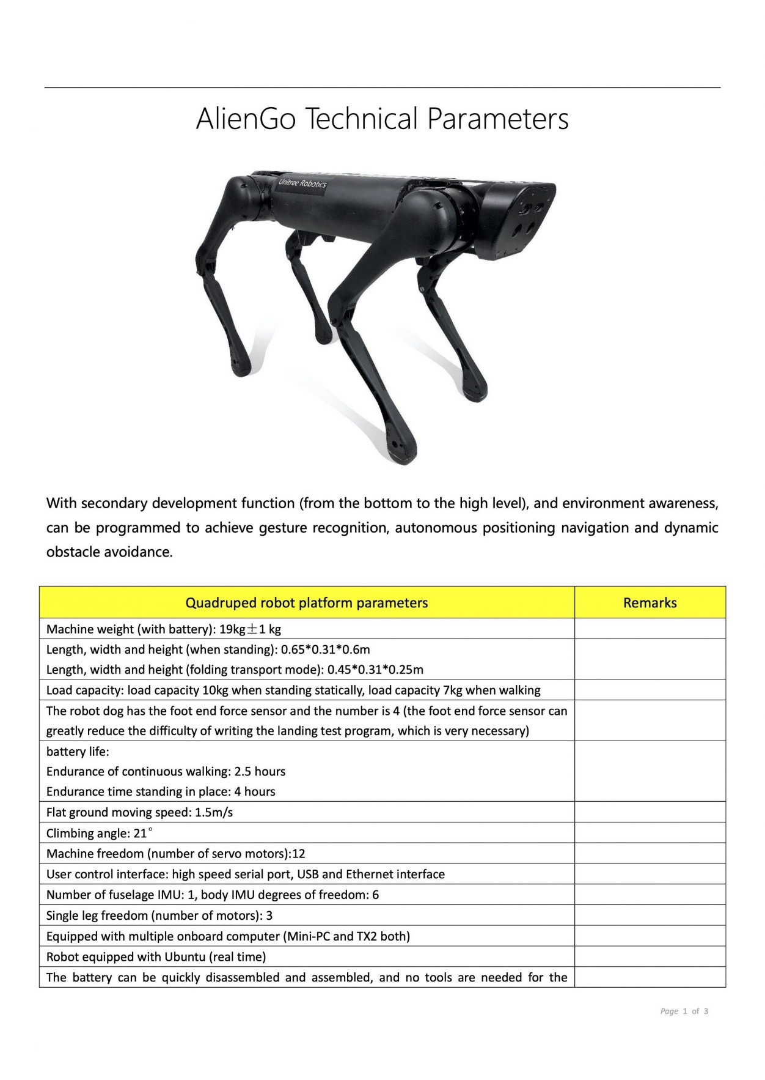

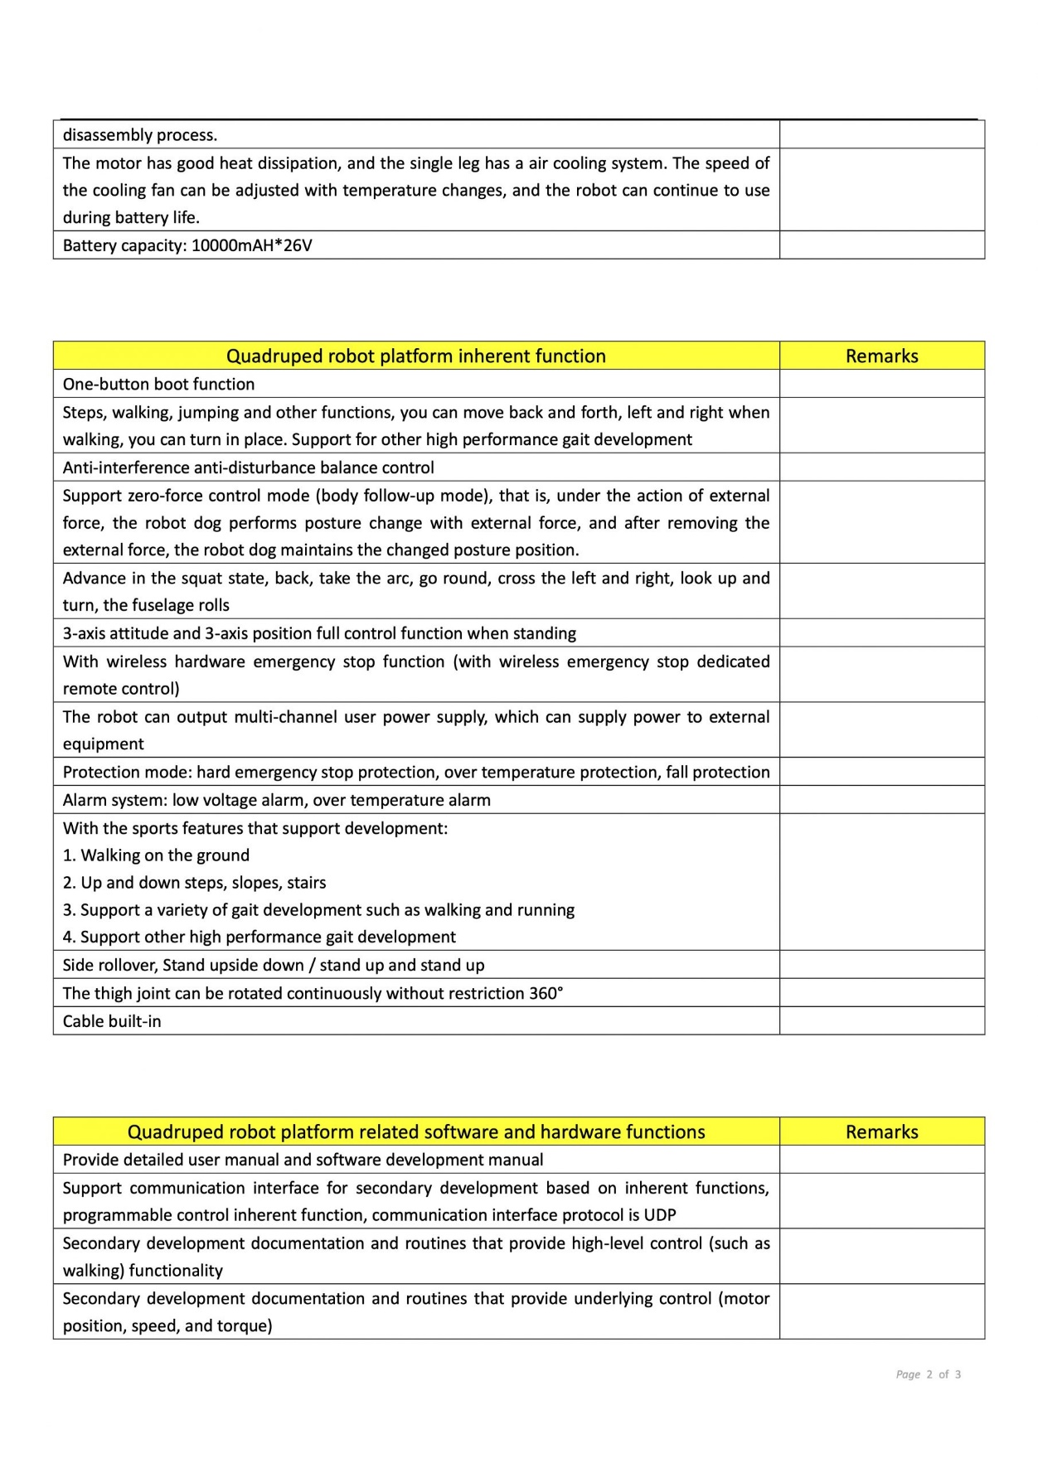

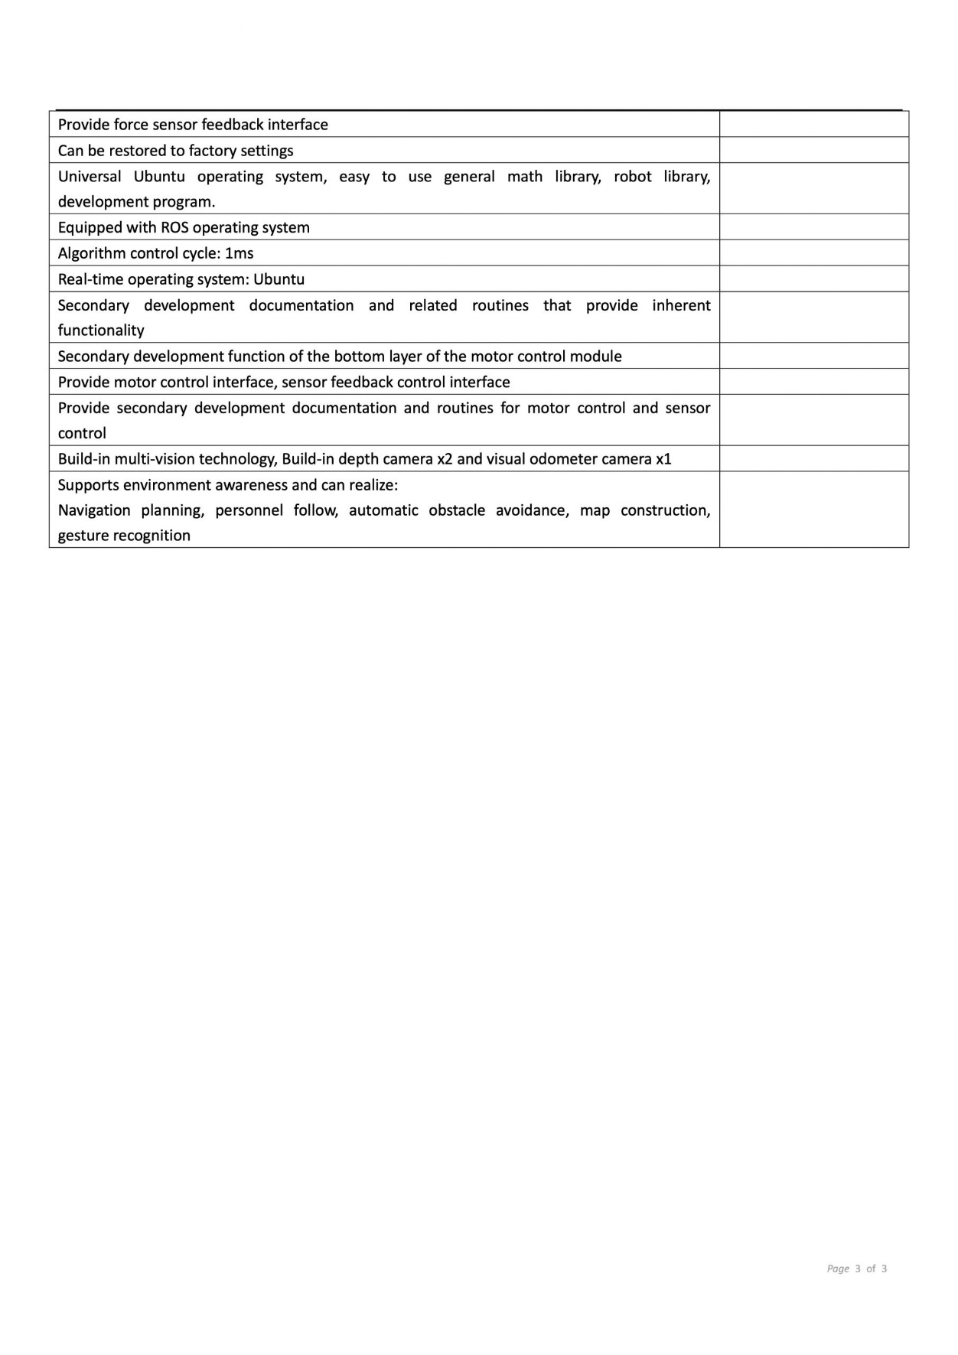

Fig. A1: AlienGo Technical Specifications

## Appendix B: Derivation of Equation 1

For a robotic arm with n-links, the maximum torque is experienced at the base when the arm is fully stretched out to the side. Assuming a modular design with the same motors,

For n-links, the torque at the base is

$$T_{n}= \left[nm_{p}+\left(\frac{n}{2}+\frac{n\left(n-1\right)}{2}\right)m_{l}+\frac{n\left(n-1\right)}{2}m_{m}\right]gl$$

$= \left[nm_{p}+\frac{n^{2}}{2}m_{l}+\frac{n^{2}}{2}m_{m}-\frac{n}{2}m_{m}\right]gl$

$= \left[\frac{{(m}_{l}+m_{m})}{2}n^{2}+\left(m_{p}-\frac{m_{m}}{2} \right)n\right]gl$

$T_{n}= \left[\frac{{(m}_{l}+m_{m})}{2}n^{2}+\left(m_{p}-\frac{m_{m}}{2} \right)n\right]gl$ (Equation 1)

Assuming 4 aluminium extrusions of 25mm square, the mass will be 4 x 0.8kg/m = 3.2kg/m (Misumi HFS5-2525)

Assuming link length, l = 0.5m, each link mass, $m_{l}$ = 1.6kg

Acceleration due to gravity is 9.81 ${m/s}^{2}$

Payload mass is $m_{p}$ = 2kg

For Dynamixel Pro H54P-200 Series ($2.6k)

Torque, $T_{m}$ = 44.7Nm, Motor mass, $m_{m}$ = 0.855kg

Need $T_{m}> T_{n}$ = $[(\frac{1.6+0.855}{2}n^{2}+(2-\frac{0.855}{2}n](9.81)(0.5)$

$$9.11>1.2275n^{2}+1.5725n$$

The largest n that fulfills the inequality as n = 2.

For Parker Pneumatic Rotary Vane Air Motor P1V-S series,

$T_{m}$ = 600Nm, $m_{m}$ = 9.7kg

$$600Nm>[(\frac{1.6+9.7}{2})n^{2}+(2-\frac{9.7}{2})n](9.81)(0.5)$$

$$122>5.65n^{2}-2.85n$$

The largest n is n = 4.

## Appendix C: Table of Feasibility Calculations

Table CI: Motor Feasibility Calculations for Equation 1

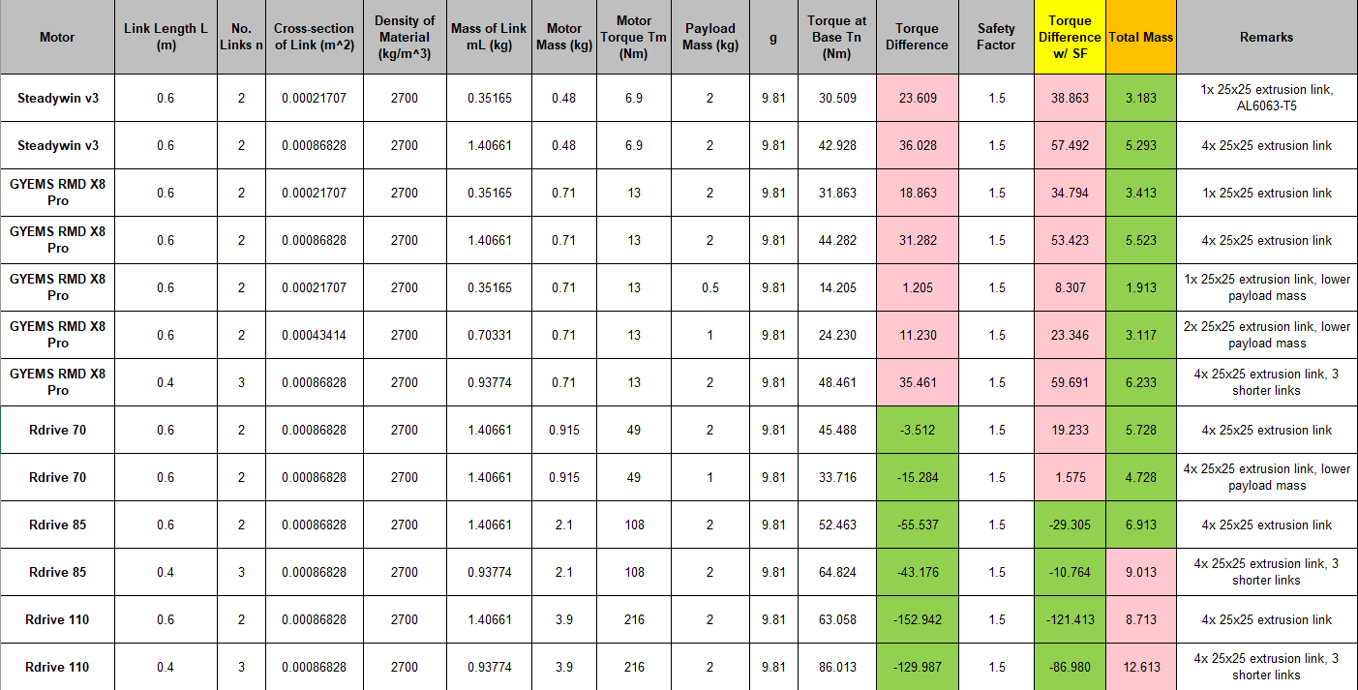

## Appendix D: Figures for Finite Element Analysis of Pitch Motor and Bearing Mount

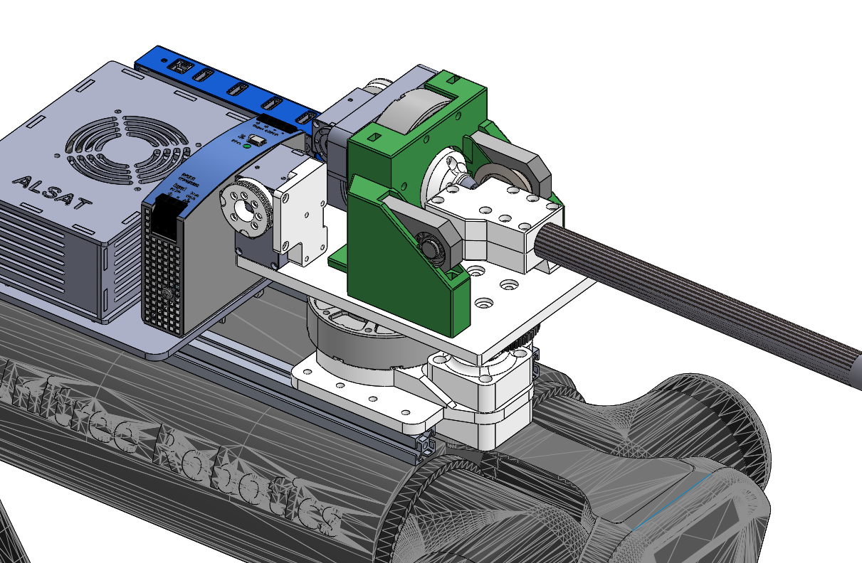

Fig. D1: CAD Highlight of Pitch Motor and Bearing Mount

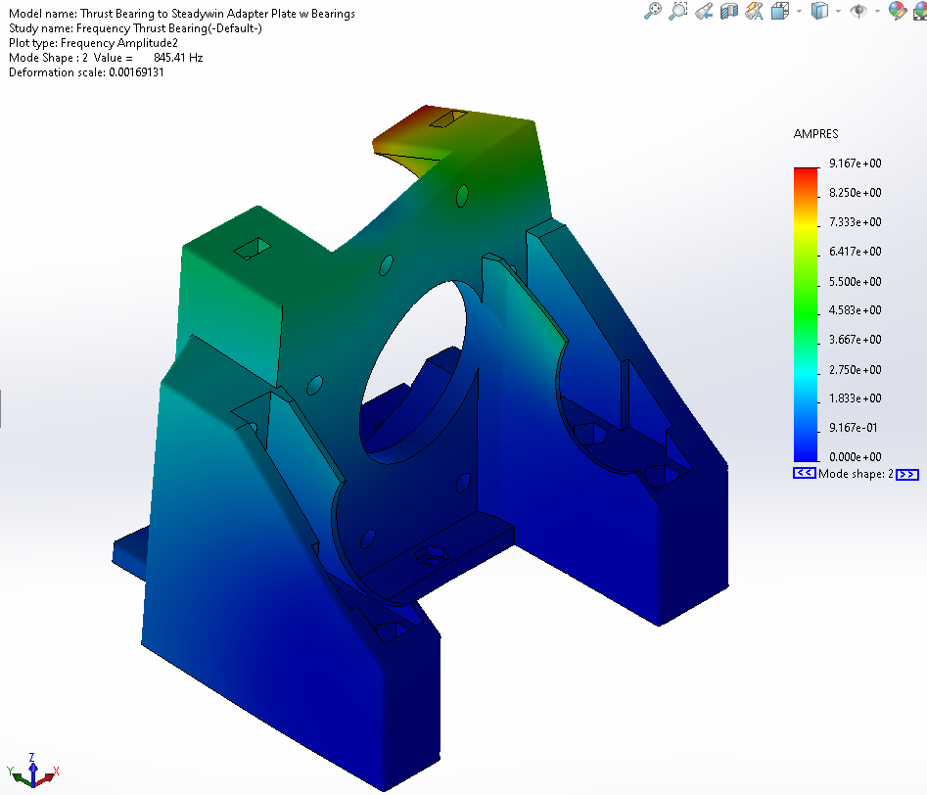

Fig. D2: Frequency Analysis of Pitch Motor and Bearing Mount (2)

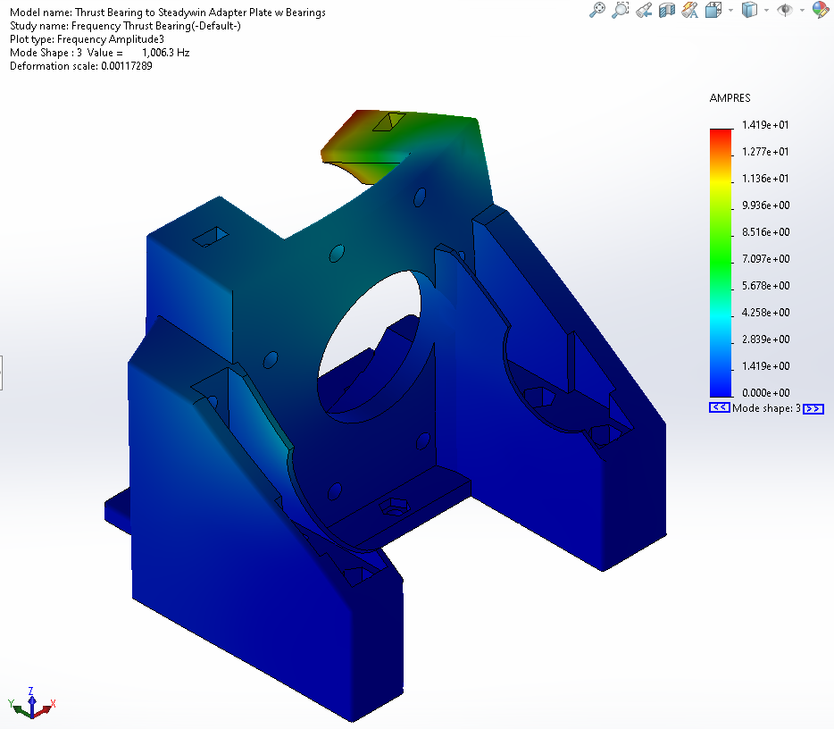

Fig. D3: Frequency Analysis of Pitch Motor and Bearing Mount (3)

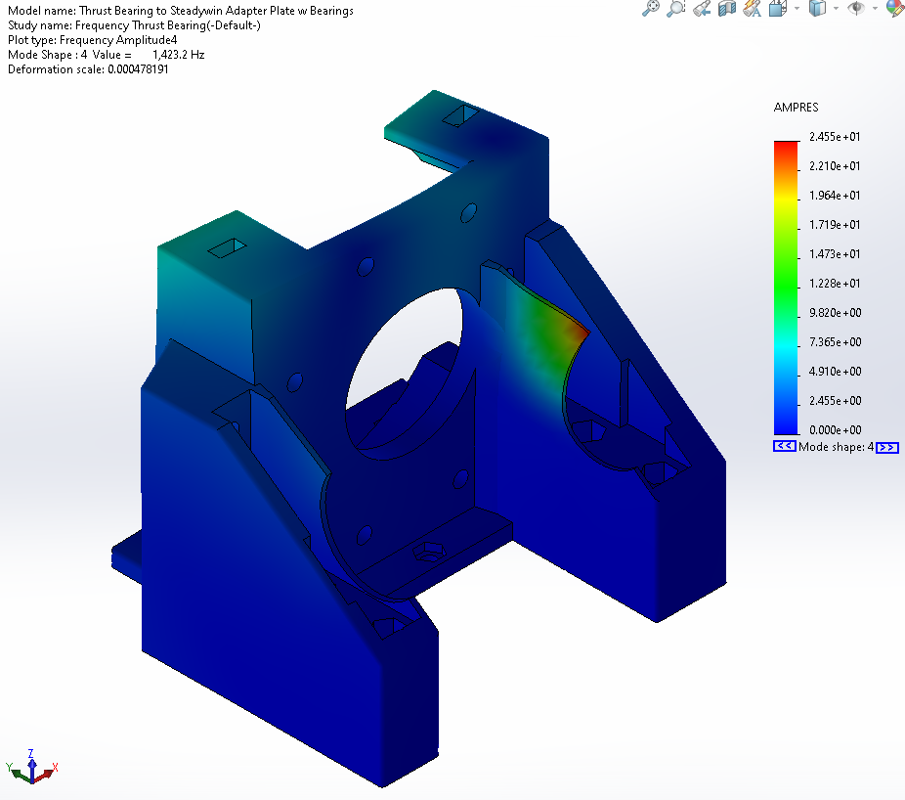

Fig. D4: Frequency Analysis of Pitch Motor and Bearing Mount (4)

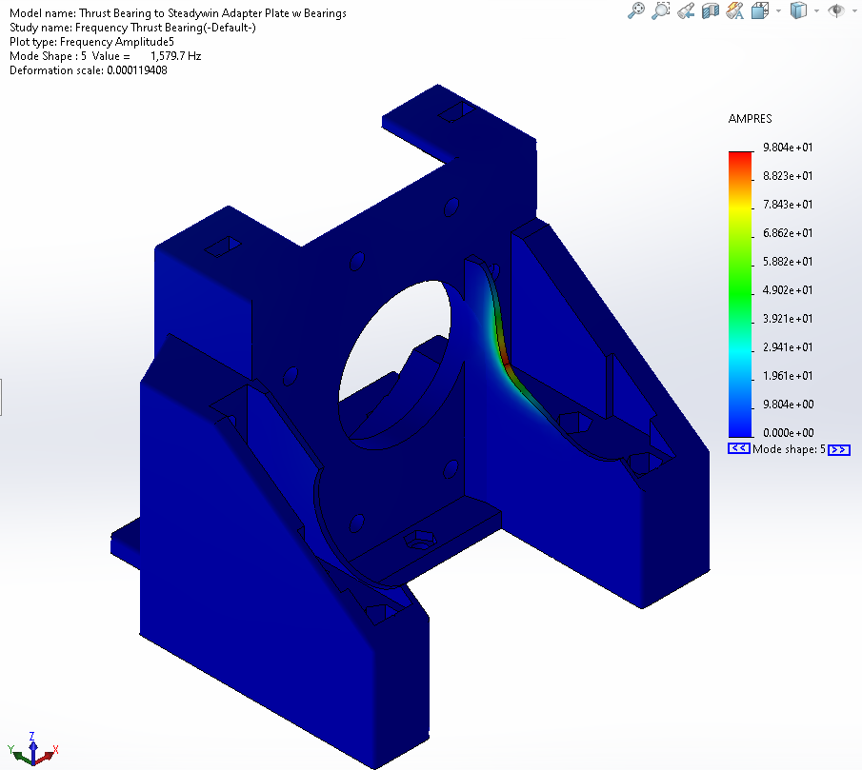

Fig. D5: Frequency Analysis of Pitch Motor and Bearing Mount (5)

## Appendix E: Figures for Finite Element Analysis of Grass-Cutter Wrist Mount

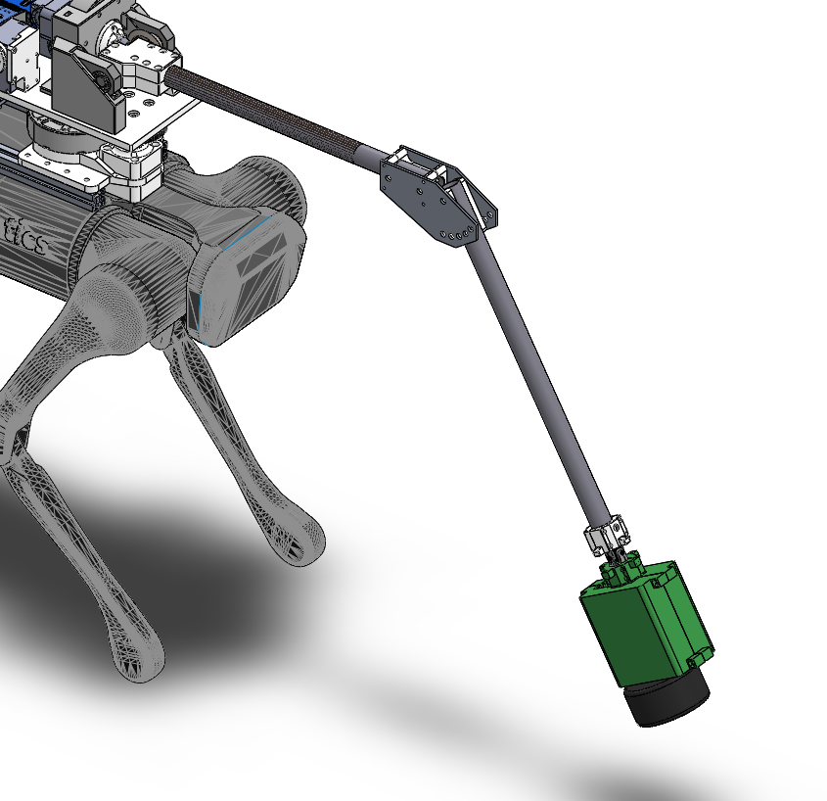

Fig. E1: CAD Highlight of Grass-Cutter Wrist Mount

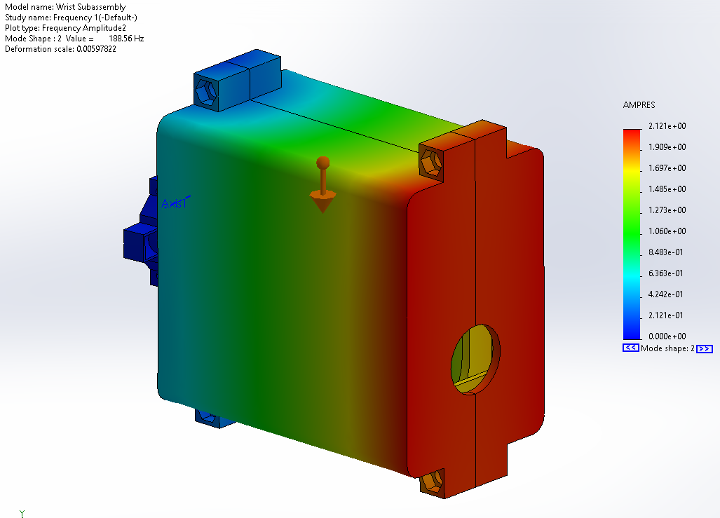

Fig. E2: Frequency Analysis of Grass-Cutter Wrist Mount (2)

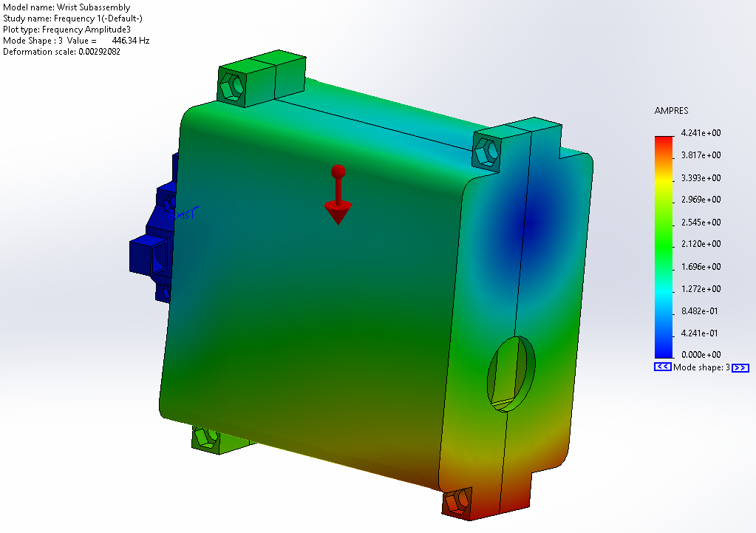

Fig. E3: Frequency Analysis of Grass-Cutter Wrist Mount (3)

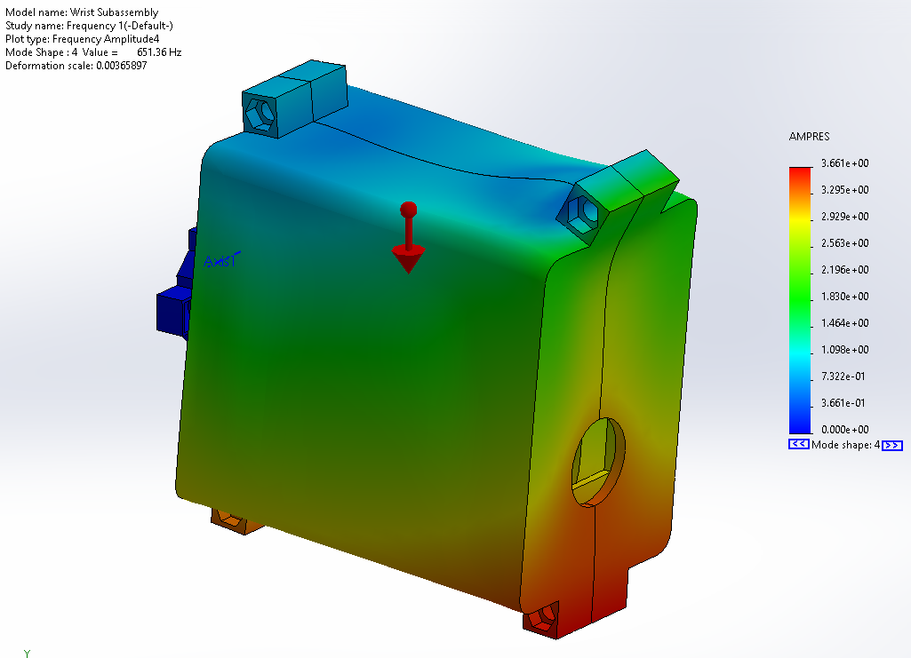

Fig. E4: Frequency Analysis of Grass-Cutter Wrist Mount (4)

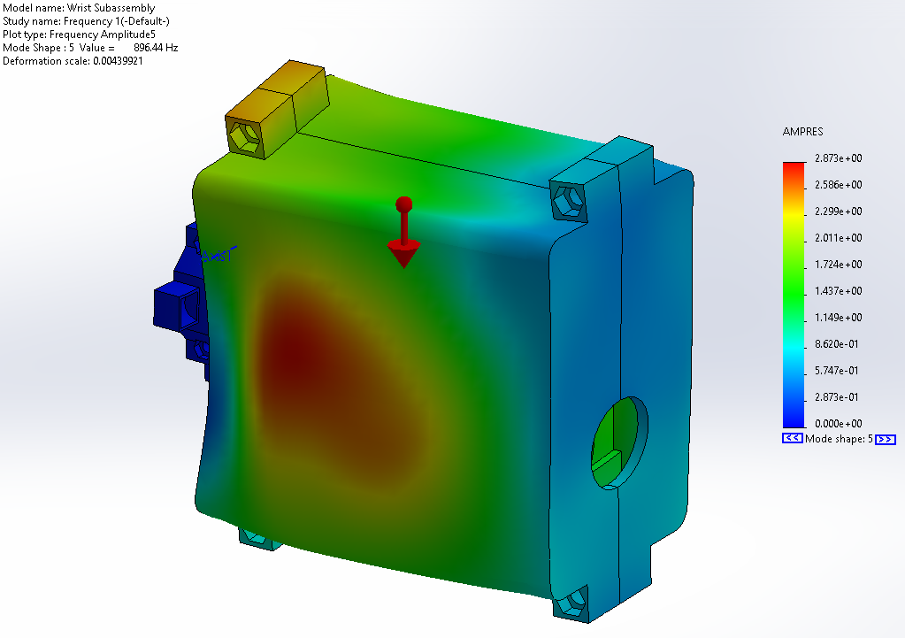

Fig. E5: Frequency Analysis of Grass-Cutter Wrist Mount (5)

## Appendix F: Figures for Balance Testing Results

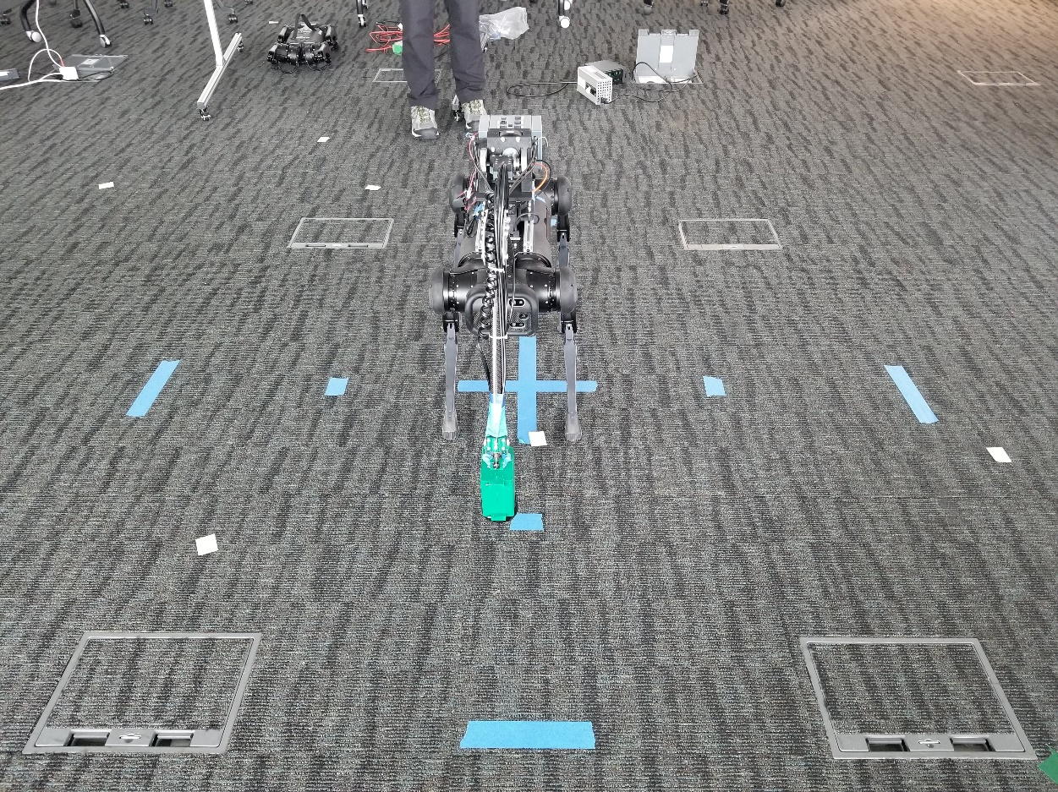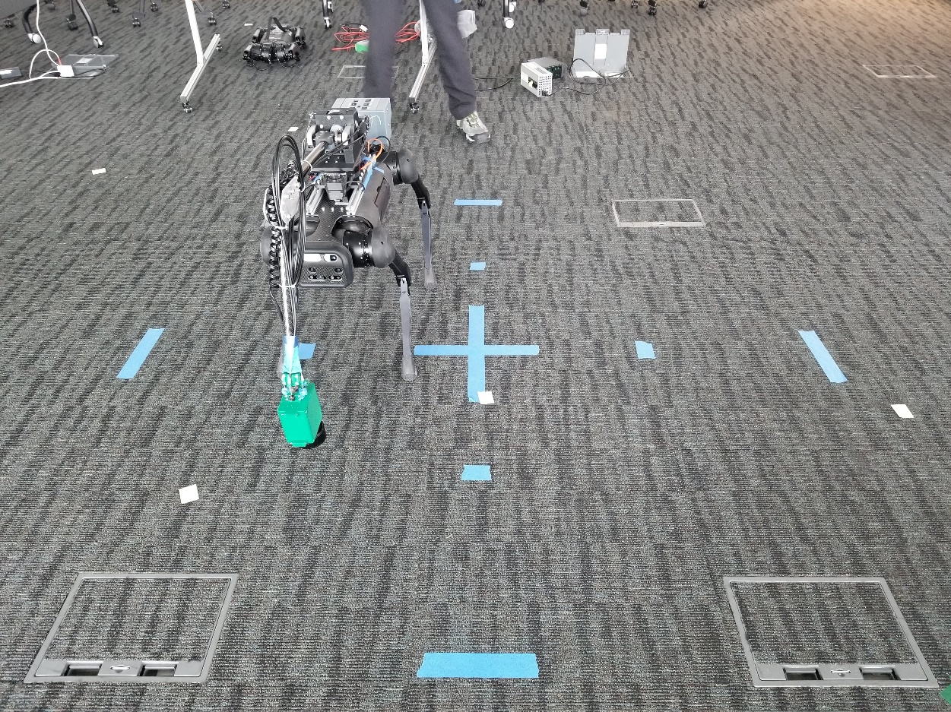

Fig. F1: Balance Test Start/Result for 0 Degree Angle (1)

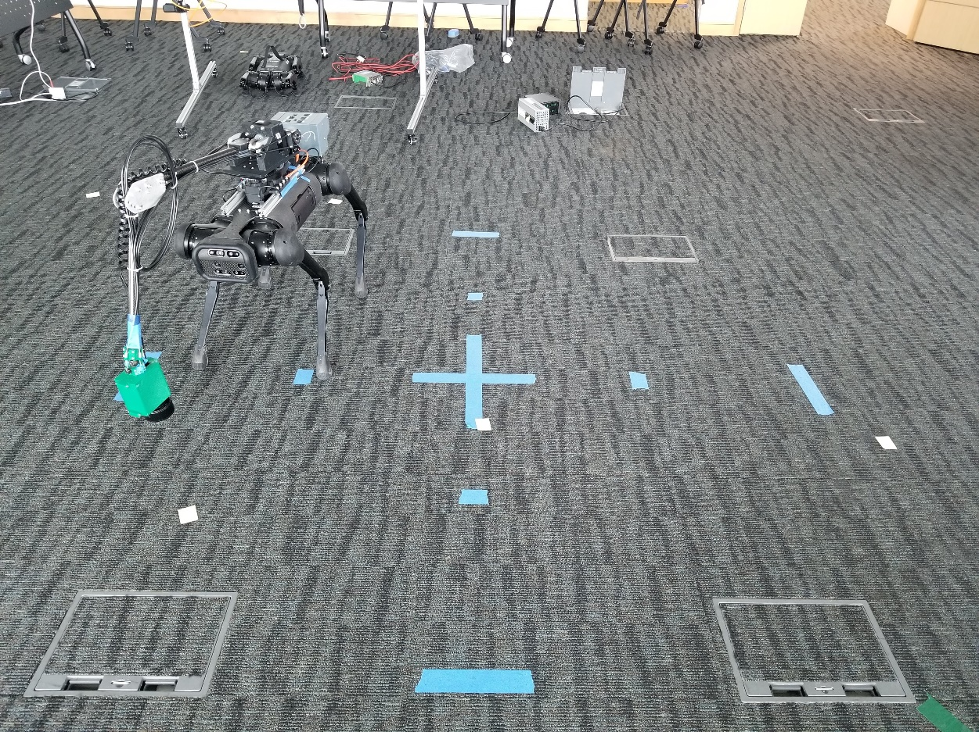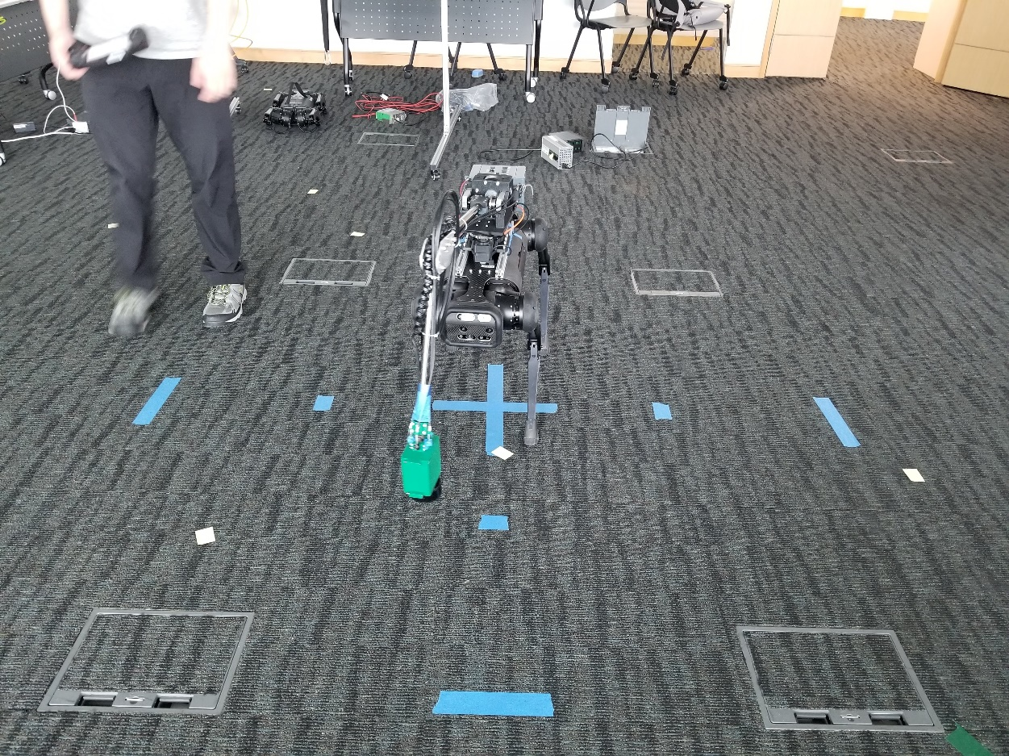

Fig. F2: Balance Test Start/Result for 15 Degree Angle

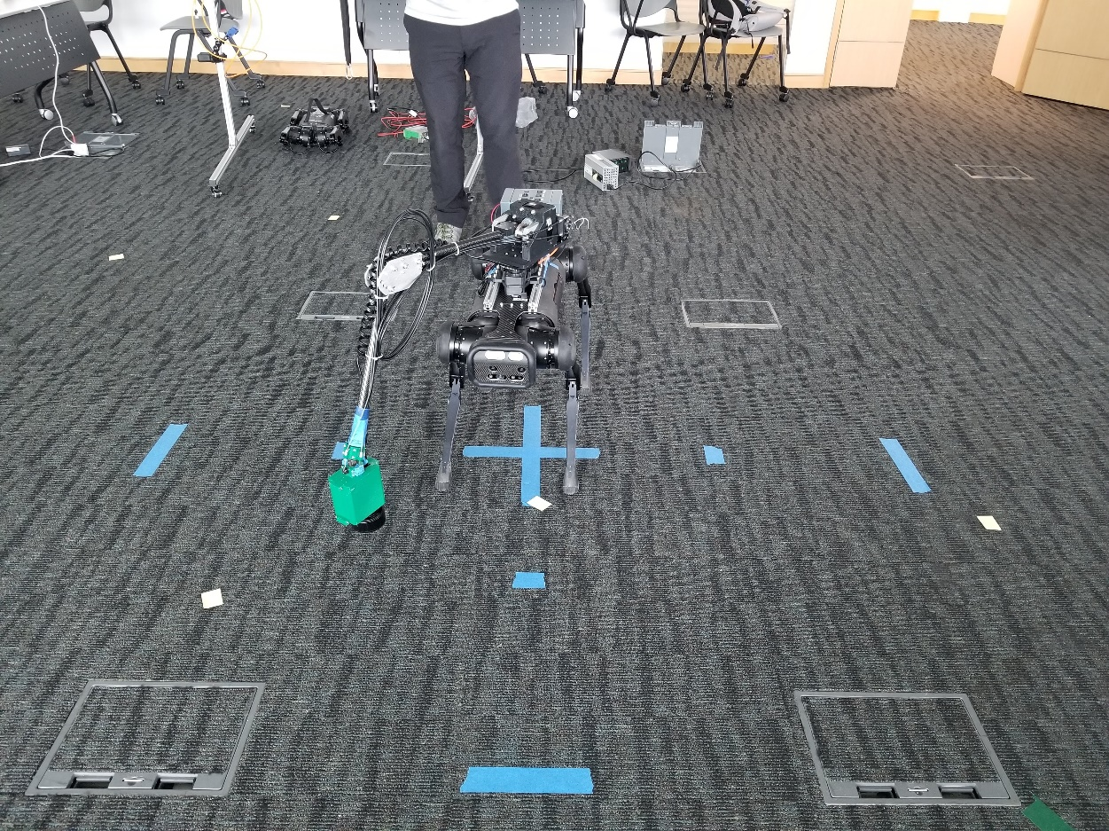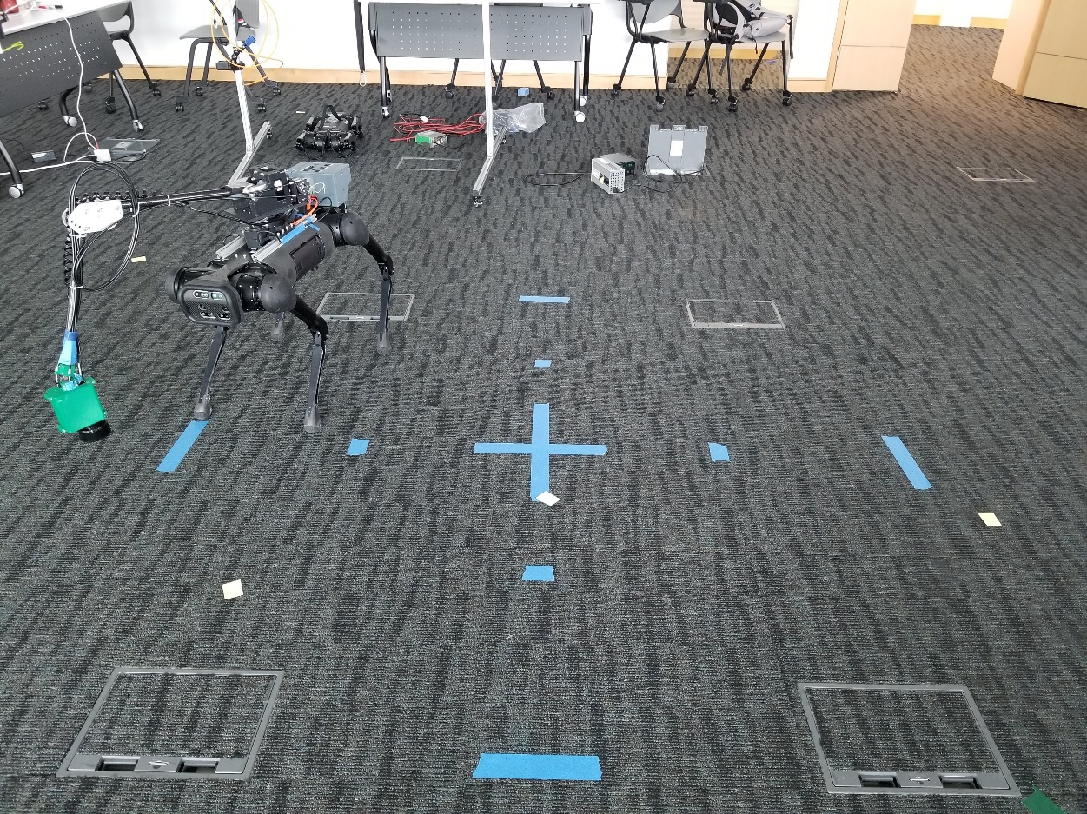

Fig. F3: Balance Test Start/Result for 30 Degree Angle

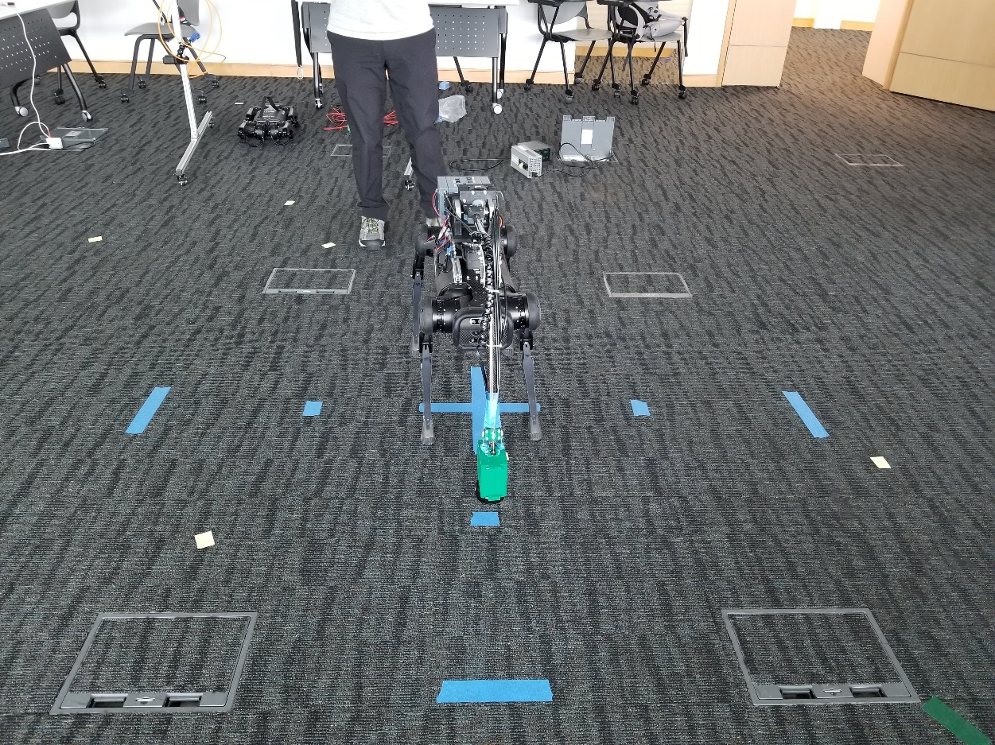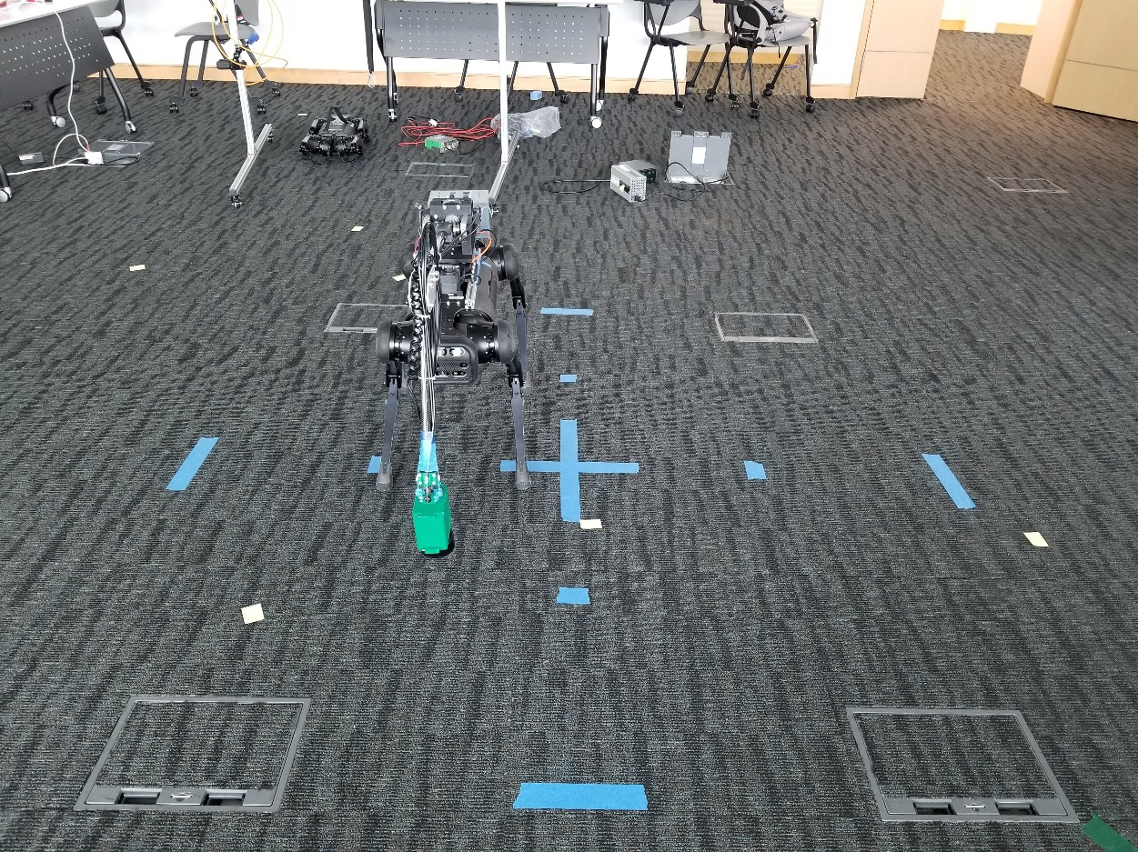

Fig. F4: Balance Test Start/Result for 0 Degree Angle (2)

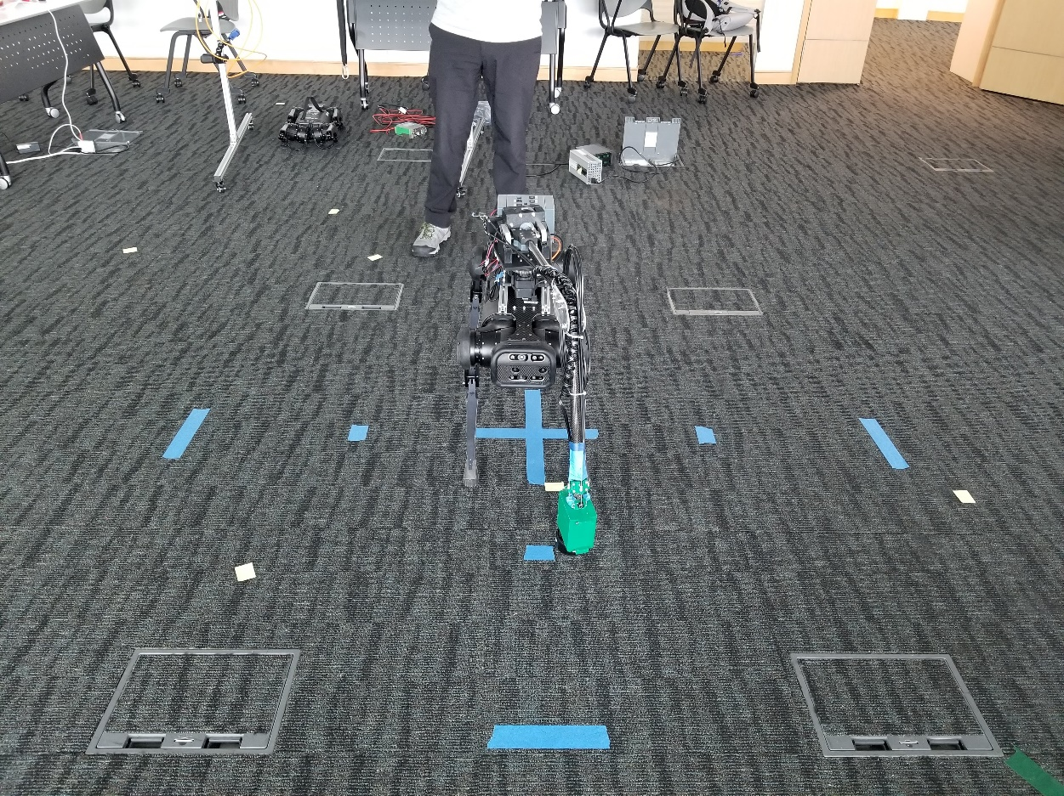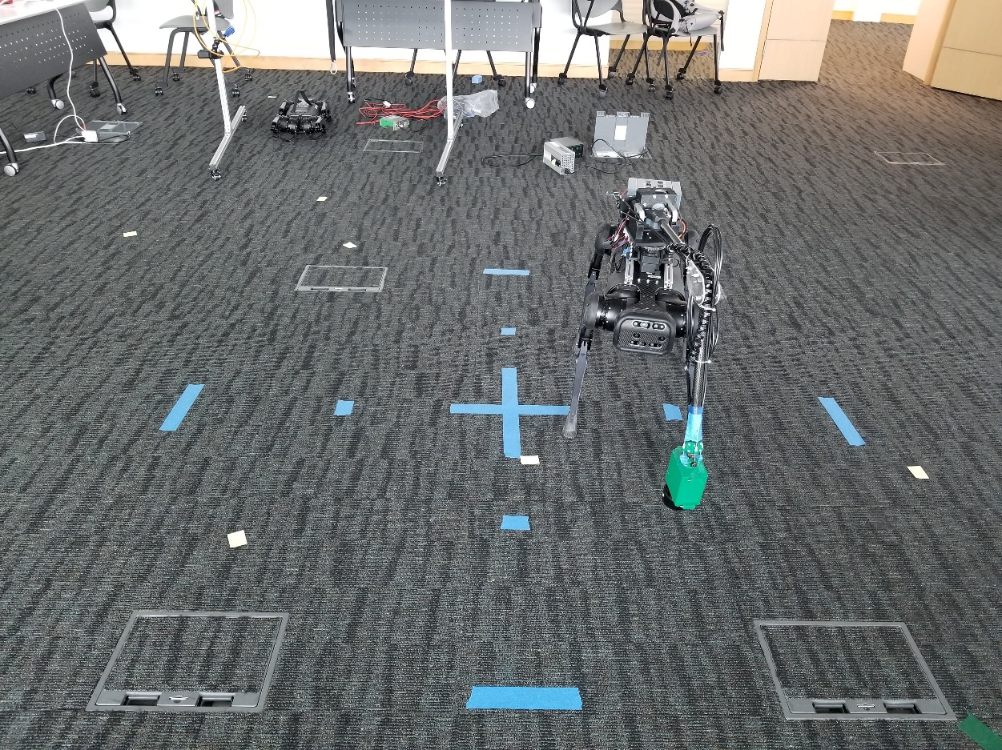Fig. F5: Balance Test Start/Result for -15 Degree Angle 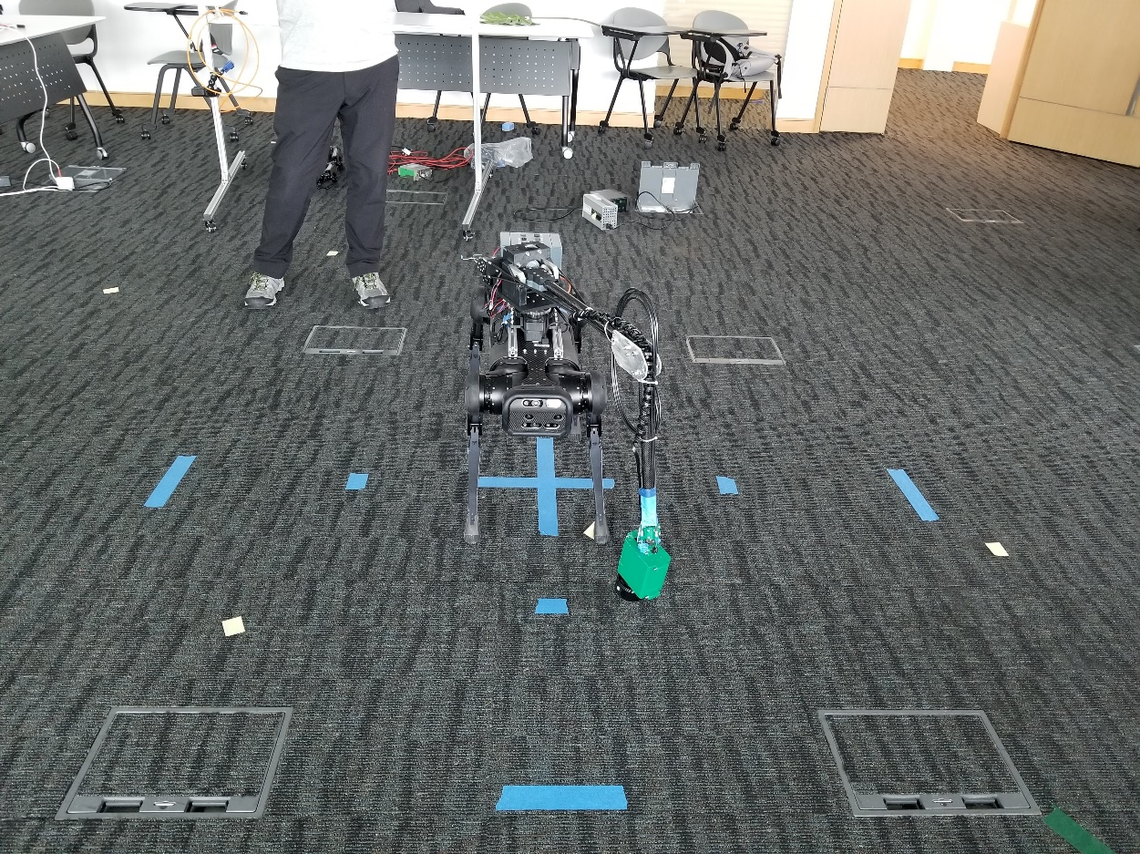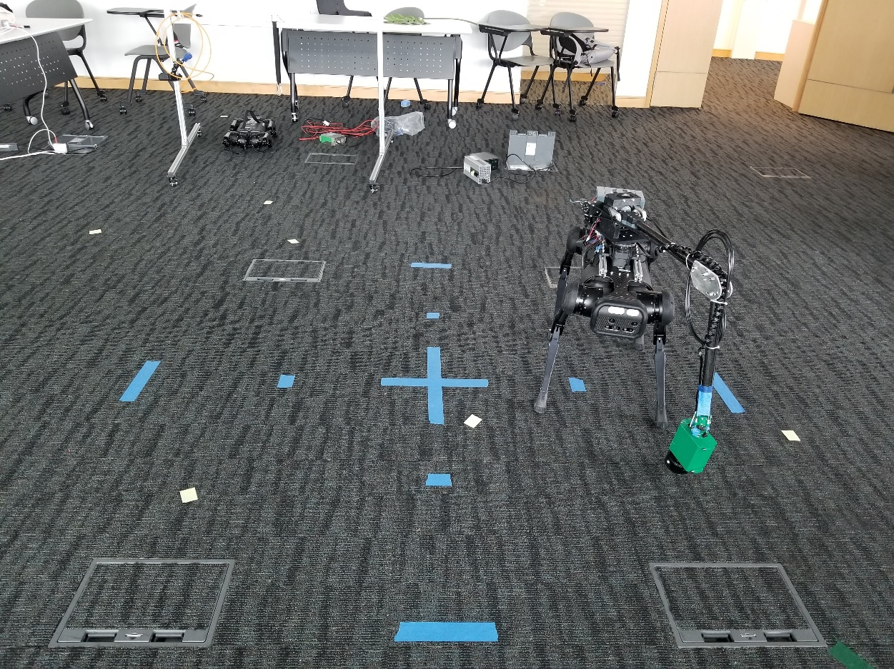

Fig. F6: Balance Test Start/Result for -30 Degree Angle

1. The video for the balance test can be found at: https://youtu.be/U8V_HvCcKe8
2. The video for the first performance test can be found at: https://youtu.be/YKuMBbeyk0w
3. The video for the second performance test can be found at: https://youtu.be/hTpGyX_BQHQ